NatureGate®, concept mapping and CmapTools: Creating global networks of servers for improved learning about, in and for nature, ecosystems, biodiversity,
and sustainable development

Mauri Åhlberg, Eija Lehmuskallio and Jouko Lehmuskallio
Department of Applied Sciences of Education, University of Helsinki
(contact: mauri.ahlberg@helsinki.fi)

Paper submitted for CMC 2006 - Second International Conference on Concept Mapping
San José, Costa Rica - September 5-8, 2006

Abstract NatureGate® innovation is described and analyzed using concept maps and CmapTools. First, it is shown , that there is new kind of free services like Google, which however create plenty of added values for individuals, societies and the whole humankind. At the same time they produce sustainable profits also to the original founders and keepers of those services. NatureGate® could be that kind of service. Both individuals and societies need knowledge about their organisms and ecosystems. CmapTools could be integrated with all the servers. It could be used for both individual and social knowledge arrangement, and knowledge management. In the paper eight questions are asked from the partners of NatureGate®. Only parts of the long answers can be analyzed in this short paper. It is easy to see, that there are many shared concepts and propositions in the answers of the three partners of NatureGate®. On the other hand there are plenty of complementary viewpoints. Concept maps probably provide basis for improving shared understanding, better than oral discussion or ordinary writing alone. Also communication for larger public is probably better when using concept maps than only speaking or writing. These are emerged hypotheses to be tested in later research.
Category/Categoría: Full Paper/Artículo Completo

Introduction
NatureGate® is a new idea, a social innovation, which was registered as a trademark in November 2005. The application for trademark was made in March 2005. In this article concept mapping is used to analyse thinking of the two founders of NatureGate®. The senior author of the article has long used and developed concept mapping as research tool. Eight interview questions were used to find out the main comparable points both founders of NatureGate®. Interviews and their concept mapping analysis show great richness of thinking of the founders of NatureGate®. Each of them has own strengths, they share the same core vision and have complementary ideas. The senior author has been invited as a partner into becoming NatureGate® Inc. All of the partners seem to have plenty to offer for the global NatureGate® business and R&D program. The idea of using both CmapTools and NatureGate® in the same servers is presented and justified.

For general public, for the most educators and business people, concept mapping and CmapTools are still innovations, perhaps vaguely heard, often misunderstood and not adopted and applied in their own work and life. Concept mapping is an innovation in sense of modern theories of innovation (Rogers 1995; Sternberg, Pretz & Kaufman 2003). There is a difference between creative invention and useful innovation. Not all inventions are useful. Innovations are both creative and useful inventions. An innovation is an idea, practice, or object that is new for an individual or organization or other “unit of adoption” (the largest one is humankind). Spread of innovations is a well researched field. Rogers (1995) claims that his book is a synthesis of over 3800 diffusion theory publications. Diffusion of concept mapping and CmapTools as innovations is still waiting for its research. This article is an example how these three innovations can be integrated in service of research, and business development.

Business idea

Vise & Malseed (2005) have written a book about Google, its history and analysis of its amazing development during a couple of years into one of the biggest and most valuable companies in the world. Battelle (2005) has good grounds to his claim that Google and its rivals have transformed both business and the whole culture by the web search-activities which they created. The idea of NatureGate® is like “NatureGoogle”, a free service, which however creates plenty of added values and business opportunities for everybody, both individuals, societies, and organizations, for the whole humankind. The reason why we dare to present the idea in public is that the concept of NatureGate is trademarked and registered, and it uses patented fast digital software to identify plants, animal, other organisms or practically any objects. Nobody can legally steal the idea. Also the time and expertise to create sufficiently high quality photographs is very demanding. It takes about a decade to become an expert in any field. The partners of NatureGate® have collectively expertise needed in order to be and sustain at the leading edge in this nature business.

Research problems
In order to promote the R&D project of NatureGate®, it is important to know what the two founding partners think about NatureGate®,. Vise & Malseed (2005) and Battelle (2005) are popular books of the similar theme. They are important and interesting, but not as systematic as social research is as its best. Åhlberg (1997) has written a systematic overview of these kinds of issues from viewpoints of continual quality improvement and high quality learning. In management literature, vision is one of the most basic aspects of any organization. At least it ought to be researched and developed. Historical phases and foundations of any social program and organization are very important parts in understanding it. They ought to be researched on. Questions of task of each member of organization and how her/his task(s) or roles are connected to the vision of the organization in each partner’s thinking are important issues (Fraser 1993). There are questions of sources of frustrations and rewards, which are important in deep understanding of any organization, even in its beginning phases (e.g. Fraser 1993).

The accurate research questions for both of the founding partners and the first invited partner were as follows
• When did basic ideas of NatureGate® emerge into your mind? How did it happen? What have been the most basic phases of NatureGate® ?
• What is vision of NatureGate® ?
• What is an ideal structure of NatureGate®? What are the functions, which at least ought to be included into NatureGate®? What else ought to be included later on into NatureGate®?
• What are your roles/tasks in NatureGate® implementation?
• How your role/tasks are connected with the vision of NatureGate® ?
• What frustrates you in implementation of NatureGate®?
• What rewards you in implementation of NatureGate®?
• What else would you like to tell about NatureGate® and about this interview?

Answers to these questions and their concept mapping are important in promoting shared understanding in any organization (Fraser 1993, Åhlberg 1997, Åhlberg 2004c).

Methods
The eight research questions were sent by email and answers were received by email. The quality and details of the answers were excellent. The senior author has been with the subjects eleven days (April 3 – 13, 2006), and discussed all the researched issues orally during a visit to San Francisco Bay Area and the following centres of excellence: (1) Stanford Centre for Innovations in Learning (SCIL) and The Third Conference on Innovation Journalism at Stanford University, (2) UC Berkeley, Centre for the Information Technology Research in Interest of Society (CITRIS) and Departments of Integrative Biology and its Jepson Herbaria, and (3) California Academy of Sciences, its Natural History Museum, in particular Botany Department, and persons responsible for Exhibits). The answers to the eight interview questions are more detailed than those impressions and conceptions which were earlier created on basis of long discussions and presentations of the NatureGate® innovation.

The interview questions are theoretically based on Fraser (1993) and Åhlberg (1997, 2004a – 2004c). The answers are coherent and meaningful, and as far as it is possible to audit, they correspond reality. All three research subjects feel that the research is valuable and important for them and for implementation of the NatureGate®. Eija Lehmuskallio’s anwers took four A4 pages. Jouko Lehmuskallio’s anwers took two A4 pages. Mauri Åhlberg’s answers took two A4 pages. Because the answers were long, only parts of them are concept mapped (Figures 1 - 5). In the texts attached to figures more details of research methods are discussed.

Results
Preliminary and illustrative results are first presented as concept maps (Figures 1 – 5) and in their interpretation.

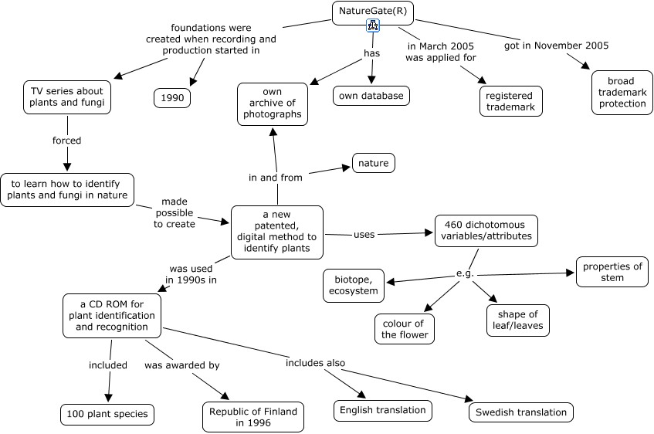
Figure 1. A part of Eija Lehmuskallio’s long answer to the question of history of NatureGate® innovation. The most central concept based on number of links with other concepts is ‘NatureGate®’ (six links). The next concepts in centrality based on number of links with other concepts are with five links each: ‘a new patented, digital method to identify plants’, ‘460 dichotomous variables/attributes’ and ‘a CD ROM for plant identification and recgnition’. An icon in the frame of ‘NatureGate®’, shows that it is linked to another concept map. If the document would be on the CmapServer as a concept maps, then a hypertext could be created.
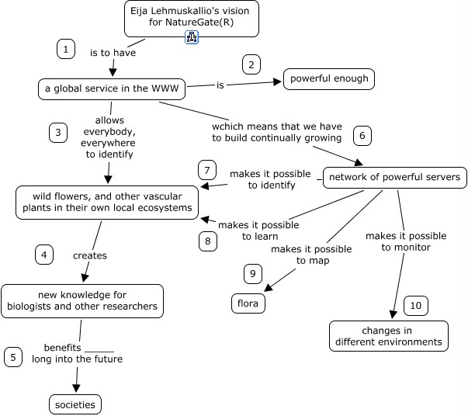
Figure 2. A part of Eija Lehmuskallio’s vision on NatureGate® innovation. Links are numbered according to in which order they are supposed to be read. This system was created by Åhlberg in 1989 (Åhlberg 1989 and 1990). In the links there are empty spaces created by a bottom line. It means that you are expected to take the concept from the end of the arrowhead and locate it on the lines. In this ways a meaningful proposition is created. This system developed by Åhlberg (e.g. 1997) is very practical in languages like Finnish, which have plenty of endings is used in the words.

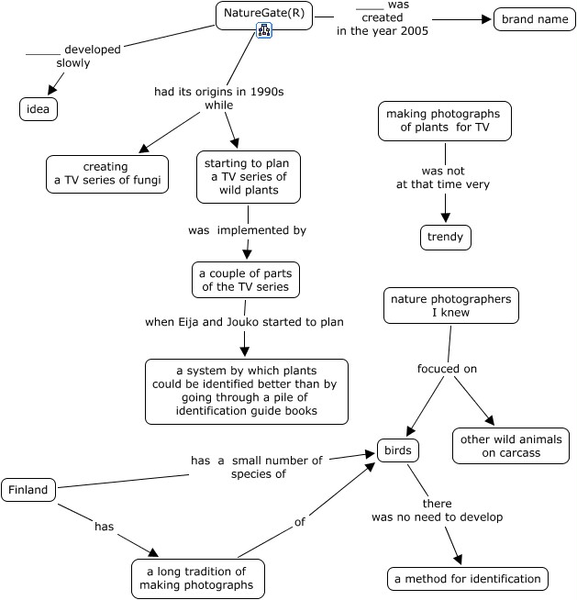

Figure 3. A part of Jouko Lehmuskallio’s long answer to the question of the history of NatureGate® innovation. It may look funny that there are three separate partial concept maps. This is the artifact created by the way concept mapping is used here. Propositions are transformed into a concept map proposition by proposition. If no connection is named, then it is not shown. The original text is coherent. This kind of use of concept mapping shows clearly where extra proposition could to be added to improve the clarity of the original text. This method of transforming any text or discourse into a concept map and back again is developed by Åhlberg (1990 and 1997). The most central concept based on number of links between concepts are ‘NatureGate®’ and ‘birds’ (four links with other concepts).

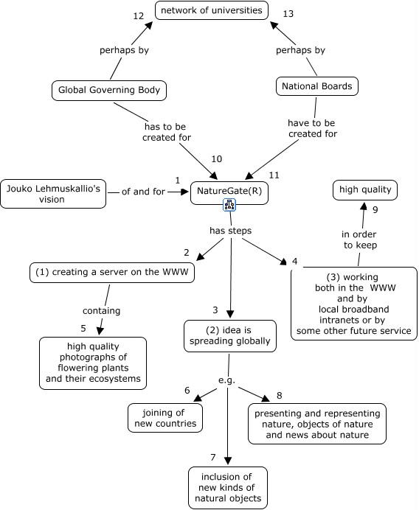

Figure 4. A part of Jouko Lehmuskallio’s long answer to the question about the vision of NatureGate®. Based on number of links with other concepts, the most central concept is ‘NatureGate®’. The next concept in centrality is the second step in his thinking: ‘idea is spreading globally’. This concept has four links with other concepts. As a qualitative interpretation of the interviews and this concept maps: It is very important that both Jouko and Eija Lehmuskallio understand the great importance of universities, research centres, and scientific research in creation, and continually testing, checking and validating knowledge.

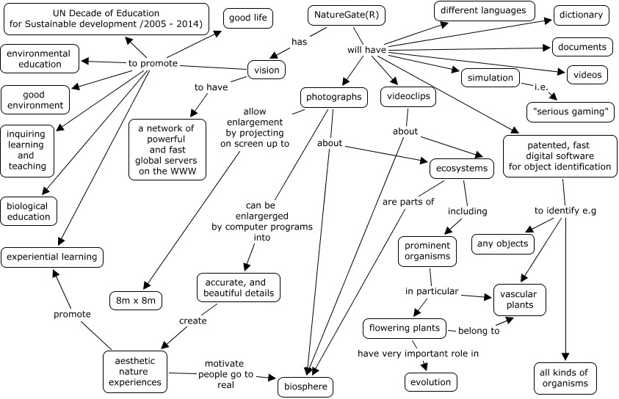

Figure 5. Mauri Åhlberg’s integrating overview based on three months learning and thinking of NatureGate® innovation, stimulated by long discussions with Eija and Jouko Lehmuskallio. Based on number of links with other concepts the most central concepts in this concept maps are ‘NatureGate®.’ and ‘vision’. Both of them have nine links with other concepts. The next of centrality are the following concepts: ‘biosphere’, ‘ecosystems’ and ‘patented, fast digital identification software’. Each of them has four links with other concepts.

Discussion
Space does not allow a detailed discussion. The results speak for themselves. It is very probable, that NatureGate®, when realized, will promote learning about, in and for nature, ecosystems, biodiversity, and sustainable development. If the space would allow, then concept maps could be compared concept by concept and proposition by proposition using comparison tables (e.g. Åhlberg, Turja and Robinson 2003). The partners of Naturegate® (Eija and Jouko Lehmuskallio and Mauri Åhlberg) feel satisfied of improved shared understanding and this possibility to communicate some of the core ideas of the NatureGate® innovation for broader academic audience. It would be ideal to present this paper as a hypertext by CmapTools. The possibility is hinted by Hoffman, Coeffey, Novak & Canas (2005). But even in the Second International Conference on Concept Mapping it is not possible, although the CmapTools software and server services are already available, free of charge, practically for everybody.
References
Åhlberg, M. 1989. Environmental educators need conceptual innovations and scientific ontology and epistemology. In Meisalo, V. & Kuitunen, H. (Eds.) Innovations in the science and technology education. Proceedings of the Second Nordic Conference on Science and Technology education. National Board of General Education. Information Bulletin 2, 280-286.
Åhlberg, M. 1990.Concept mapping and other graphical knowledge representation methods as tools for teachers and pupils (in Finnish).University of Joensuu. Research Reports of the Faculty of Education N:o 30.
Åhlberg, M. 1993. Concept maps, Vee diagrams and Rhetorical Argumentation (RA) Analysis: Three educational theory-based tools to facilitate meaningful learning. Paper presented in The Third International Seminar on Misconceptions in Science and Mathematics. August 1- 5, 1993. Cornell University. Published digitally in the Proceedings of the Seminar, http://www.mlrg.org/proc3abstracts.html The whole paper is available from: http://www.helsinki.fi/sokla/bgee/Ahlberg_Cornell_1993.doc

Åhlberg, M. 1997. Continual Quality Improvement as High Quality Learning (in Finnish). University of Joensuu. Research Reports of the Faculty of Education N:o 68.

Åhlberg, M. 2004a.Varieties of concept mapping. In Canas, A., Novak, J., Gonzales, F. (Eds.) Concept Maps: Theory, Methodology, Technology. Proceedings of the First International Conference on Concept mapping. CMC 2004. Pamplona, Spain, Sept 14 – 17, Vol. 2, 25- 28, http://cmc.ihmc.us/papers/cmc2004-206.pdf

Åhlberg, M. 2004b. Concept mapping for sustainable development. In Canas, A., Novak, J., Gonzales, F. (Eds.) Concept Maps: Theory, Methodology, Technology. Proceedings of the First International Conference on Concept mapping. CMC 2004. Pamplona, Spain, Sept 14 – 17, Vol. 1, 39 – 44, http://cmc.ihmc.us/papers/cmc2004-233.pdf

Åhlberg, M. 2004c. Creating and testing educational theories and methods to promote Education for sustainable Development: OECD/ENSI in Finland from 1997 – 2004. A poster and handout in the thematic SEED/OECD/ENSI conference on 'School Development in the Light of Education for Sustainable Development – Challenges for Teacher Education and School’, Sep 29 to Oct 3, 2004, Kassel, Germany, http://bulsa.helsinki.fi/~maahlber/Kassel_poster_27_9_004.pdf

Åhlberg, M., Äänismaa, P. & Dillon, P. 2005. Education for sustainable living: Integrating theory, practice, design and development. Scandinavian Journal of Educational Research 49(2), 167 - 186.

Åhlberg, M., Turja, L. & Robinson, J. 2003.Educational research and development to promote sustainable development in the city of Helsinki: Helping the accessible Helsinki Programme 2001 - 2011 to achieve its goals. International Journal of Environment and Sustainable Development 2(2), 197 - 209.

Battelle, J. 2005. The search. How Google and its rivals rewrote the rules of business and transformed our culture. Boston: Nicholas Brealey Publishing.

Fraser, K. 1993. Theory based use of concept mapping in organization development: creating shared understanding as a basis for the co-operative design of work changes in working relationships. PhD dissertation. Cornell University.

Hoffman, R., Coeffey, J., Novak, J. & Canas, A. 2005. Applications of concept maps to web design and web work. In Proctor, R. & Kim-Phuong, V. (Eds.) Handbook of human factors in web design. Mahwah, NJ.: Lawrence Erlbaum Asssociates, 156 – 175.

Rogers, E. (1995) Diffusion of Innovations. Fourth Edition. New York: Free Press..

Sternberg, R., Pretz, J. & Kaufman, J. 2003. Types of innovations. In Shavina, L. (Ed.) The international handbook of innovation. Amsterdam: Elsevier, 158 – 169.

Vise, D. & Malseed, M. 2005. The Google story. New York: Bantam Dell.

