LABS in photogrammetry and LiDAR-based STRS

NOVA-Mekrijärvi
Fri June 12, 2009
Ilkka Korpela, Finland
Ilkka.korpela@helsinki.fi

Contents

1 Purpose of the exercises 1
2 Description of the demo data in C:\DATA\ 2
21 About the data and examples 2
22 Frame images 1946−2009 2
23 ADS40-pushbroom images from 2008 2
24 LiDAR data 2004, 2006-2008 2
25 DEMs (DTMs) and CHMs 2
26 KUVAMITT- digital photogrammetric software 2
3 LAB-1 Geometric properties of LiDAR and images 3
Demo − 1 Learning about KUVAMITT and our data 3
Demo – 2 Getting XYZ-coordinates manually 3
1. Monoplotting or monoscopic analysis 3
2. Least square ray intersection. 4
3. LS-ray intersection in image pairs 4
4. Pushbroom images ADS40, NIR-band 4
5. Epipolar geometry, search lines. 4
Demo – 3 Getting XYZ-coordinates semi-automatically 4
1. Using the confined search line; area-based image matching in an image pair. 4
2. Epipolar geometry, area-based image matching in an image triplet. 4
Demo – 4 Getting XYZ-coordinates almost automatically 5
3. Automatic matching inside an image polygon 5
4 Anaglyph stereo – epipolar rectification (Optional) 5
Demo – 5 LiDAR data 6
1. Plot altm2033 data in images 6
2. Plot altm3100 data in images 6
3. LiDAR; pulses or points? 6
Demo – 6 Tree measurements 7
1. Treetop positioning and tree height estimation with LiDAR monoplotting 7
2. Treetop position using LS ray intersection 7
3. Tree crown shape using non-linear regression 7
4. Tree crown width in image; semi-automatic template matching. 7
5. Treetop positioning – almost automatic 8
4 Lab 2 – RADIOMETRIC ISSUES 8
Demo 1 – the image data for XYZ point 8
Demo 2 – the 16-bit R, G, B, NIR -values 9
Demo 3 – PAN-sharpened vs. original 9
Demo 4 – Collecting LiDAR intensities 9
5 Some KUVAMITT commands: 10

1 Purpose of the exercises

The lectures and labs will expose you to IMAGES

Simple FRAME camera model (~pin-hole, ~perspective) and exterior orientation
- scanned film images, digital cameras, multi-lens systems

PUSHBROOM camera/sensor model, exterior orientation
- ADS40-(SH52) camera

Getting 3D data using images
- single image
- solving the correspondence problem
- a pair of images
- multiple images
- trying the impossible, mixing XYZ-systems in adjustment
- Automatic 2-image and 3-image matching (area-based correlation)
- Monoplotting helped by LiDAR

Superimposing 3D data in images
- frame images vs. ads40
- Measuring tree top position / 3D data capture in images
- visibility/discernibility of trees of different relative height
- manual ray intersection
- manual template matching
- manual LiDAR monoplotting
- semi-automatic, template matching

Measuring tree crown diameter / dimensions in images
- manual, xy-vector in images
- manual, template matching
- semi-automatic crown silhouette modeling

Classification of the species (RADIOMETRY)
- Effects of the scale and BRF
- Visual interpretation
- Numerical – getting the pixel samples

Model chain in STRS – computing the single tree DBH
- Role of sampling, measurement and model errors
- Regression estimation OR
- Non-parametric estimation
- How to avoid excess costs?

Image chain & imaging issues
- The image chain is a good concept!
- Weather and medium, the light sources
- Phenology, time-of-day
- Post-processing, to interpolate or not?
- PAN-sharpening, what goes on behind the scenes?
- What does it cost to fly? Implications on method / camera / vendor selection?

Labs will expose you to LiDAR, which is compared to images and examples of co-use are given in (some of the themes):

- Evaluating the XY-matches, relative and absolute
- Evaluating the Z-accuracy of LiDAR
- Effective resolution of images and LiDAR?
- FW, discrete-return or mixed systems?
- Different systems: als50 and altm3100
- Different altitudes: 1, 2, 3 and 4-km data
- LiDAR intensity; comparable between sensors?
- Backscatter amplitude, factors affecting it?

2 Description of the demo data in C:\DATA\

21 About the data and examples

The LiDAR, Image and reference tree data is from Hyytiälä, (62°N, 24°E) in southern Finland (see http://www.helsinki.fi/~korpela/HYDE_REF/). Use of the data and KUVAMITT source code is hereby limited to this NOVA-course. If you are interested in doing research with the Hyytiälä remote sensing experiment, please contact Ilkka.korpela@helsinki.fi. Joint research efforts utilizing the experiment have been launched recently involving forest, remote sensing and photogrammetry researchers in Finland, Norway, Austria and the UK.

22 Frame images 1946−2009

KUVAMITT supports 8/16-bit, non-tiled, 1- 3-, or 4-channel raw/BIP-images (C/C++ arrays of unsigned char or unsigned short data).

UltraCAM/DMC images can have the 16-bit 1-channel PAN and the 4-channel R, G, B, NIR image versions in non-tiled, raw BIP format.

Image files are always named *.raw. Each image has an ASCII *.hdr -file, which contains the interior and exterior orientation parameters in [m] and radians. KUVAMITT assumes that the images are free from lens errors or that the medium does not affect the path of the image rays. The simple collinear equations are used. Extensions are easily made, when needed, e.g. when working with consumer grade cameras.

The XYZ system is always assumed to be Cartesian; thus no Earth curvature corrections are made.

For film images with fiducial marks, a Helmert or an Affine transformation is used to convert between the row,col -system of the image and the metric xy-system of the film/focal plane in the camera. Oldest images are from 1946 and newest from 2007 (Z/I DMC images from May 31, 2009 are not processed yet).

23 ADS40-pushbroom images from 2008

The set includes some pushbroom images taken in August 2008. In-situ radiometric measurements were carried out simultaneously that allow the testing of atmospheric correction models.

The sensor model is basically the same as in Frame images, however, the orientation parameters (camera position and attitude) are given for each scan line with 2−8-ms integration time and a direct solution of the XYZ_in_object_space_to_pixel_pos routine cannot be found, but it is solved iteratively.

In a strip, alternatively 6 or 11 CCD-lines were “exposured” using integrations times between 2.3 to 8 milliseconds. Each strip yielded 6 or 11 images, or image mats, consisting of several 2GB TIFF-files. Handling of ADS40 data requires thus some additional bookkeeping because of the huge image sizes.

The *.hdr-file points to four ads40-spesific files with the needed metadata: *.ads, *.odf, *.cam, *.sup. The ads-file has metadata on the number of scan lines and image files. An *.odf file has the orientation data for each scan line. *.cam file contains the calibrated focal-plane xy-position of each pixel in the 12000-pixel line-CCDs. *.sup has the needed data for conversions between coordinate systems - there is a local Cartesian XYZ system where all photogrammetric computations are made. This is anchored to a local UTM35/WGS84 point, which is the system where the GPS/IMU observations were made during flight. Finally, these coordinates can be converted into any national system.

The images are coded per sensor line (11). “REDN00A”, for example, stand for the nadir view in the red band. There are RED, GRN, BLU, NIR and PAN images looking in Back, Nadir or Forward direction at -16 to +27 degree angles.

Flying heights in August 23, 2008 were 1, 2, 3, or 4 km corresponding to GSDs of 10, 20, 30 and 40 cm. ADS40 has 6.5 micron pixels, with an effective resolution of ~6.4 um. The DN-values convert to at-sensor irradiances using calibration coefficients provided by the sensor manufacturer.

/ ADS40 radiometry; look for papers by Ulrich Biesl
/ ADS40 geometry: Udo Templemann

24 LiDAR data 2004, 2006-2008

Folders c:\data\als2004\, c:\data\als2006\, c:\data\als2007\, and c:\data\als2008\ have LiDAR pulse records in binary 100- and 207-byte records in files ##1_##2.bin.

Altm1233-Blom, altm3100-Blom, als50-FinnMap and als50-Maa-Amet were the used sensors. Each pulse record has the following variables

- GPStime, secs from the beginning of the GPS-week
- Position and attitude of the LiDAR, in XYZ and 3 angles
- Scan angle
- 1-4 echoes with XYZ, intensity, range
- AGC & other miscellaneous parameters, depending on the sensor

The LiDAR data is processed into 1-ha binary files.

25 DEMs (DTMs) and CHMs

KUVAMITT supports raster and TIN DEMs/CHMs. In our sample files, the heights are meters above sea level in the Finnish orthometric N60 system. The data consists of 4-byte decimal number (float, single) arrays.

26 KUVAMITT- digital photogrammetric software

C:\data\kuvamitt_nova\project2.vbp starts the old Visual Basic 6.0 programming environment and opens the KUVAMITT source code project.

KUVAMITT consists of several Windows, in Form#.frm files plus supporting Visual Basic code modules in Module#.bas files. CTRL-R opens a project window, where these files (components) are listed. In addition, KUVAMITT uses two C/C++ DLLs of its own and several other 3rd-party DLL’s, e.g. by Mathworks.
In each demo, there are instructions on how to change the source code to learn about the algorithms that are included.

3 LAB-1 Geometric properties of LiDAR and images

Demo − 1 Learning about KUVAMITT and our data

a. Start C:\data\kuvamitt_nova\project2.vbp

b. Press “F5” to Run the VB code, the program starts. Be sure that the regional settings in the PC have comma as list separator and point for the decimal symbol.

c. Press “F2” to read aerial images, go to the folder c:\data\imafiles\demo1\ and select the images, one at a time by repeating the F2 read process. Read order of images: 3913, 3914, 3915, 440304! These FRAME images are centered to some buildings at the Hyytiälä forest station, University of Helsinki.

In KUVAMITT, there can be 1-9 images displayed in the main window, Form1. The F2-routine opens the images and centeres then to an XYZ-solution (using the CTRL-M command).

d. Read a raster DEM of the area: “File | Add tin or raster height models | Add raster elevation (DEM) model (*.hdr)”, select the file c:\data\HydeLiDARDEM.hdr and introduce a 0.20-m offset to the Z-data, when prompted.

All data are in KKJ-2/N60 XYZ-system, which is a Gauss-Kruger map projection for XY and orthometric heights for Z, i.e. meters a.s.l.

Now, there should be 4 images displaying a roof corner. Some image codes are imposed in white text, as well as the scale in 1:####. There is one film images (CIR, 21/23 RC20, 1.9 km) an three pan-sharpened digital CIR images (Ultracam D, 1 km).

e. Try clicking the corner of the roof in all images. You are making image observations of the corner. The text boxes above the images show the xy and (col,row) – images coordinates for the observations that you made.

Use CTRL-C to clear any graphics that hinders you from seeing the corner.

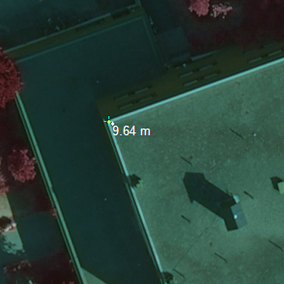
“9.64 m” is the height of some LiDAR echoes above the DTM, but let us first concentrate in the basic photogrammetric / geometric issues.

f. Pay attention to the row: “Space intersection results”: when clicking the corner in images. It shows the current XYZ-solution that KUVAMITT uses.

g. Try zooming, panning and centering images.

Keep CTRL pressed down when clicking – ZOOM OUT
Keep SHIFT pressed down when clicking – ZOOM IN
Keep ALT pressed down when clicking – PAN MODE
Try CTRL-M, it centers everything to XYZ-solution

Zooming out becomes slow after 25%; this is because KUVAMITT does not support tiled images or does not use static image (resolution) pyramids, which are used by many DPW-software.

h. Clearing images and observations. Try CTRL-A, it clears graphics and empties the text boxes.

Demo – 2 Getting XYZ-coordinates manually

1. Monoplotting or monoscopic analysis
Click the corner of the flat roof in image 3913. The select from the menu: (3D | Intersection of rays… | Point intersection, ONE image…)

When prompted for the Z of the target, give 158 m, which is our current best guess.

The solution now is

X:

Y:

Z: 158.00 m

This is what one image (two observations) can give.

2. Least square ray intersection.
Now continue by clicking the same corner in all four images. Then perform least square ray intersection (4 images = 8 observations – 3 unknowns; redundancy of 5), Press CTRL-I.

The space intersection results are:

X:

Y:

Z:

And the reliability measures are

RMSE: micrometers

SD(X): m

SD(Y): m

SD(Z): m

3. LS-ray intersection in image pairs
Let’s look at the Z solution by selecting different image pairs for the LS-ray intersection. Activate / disable images by selecting the check-box above the image. Make notes of the Z-values.

440304 – 3913, Z:

3913 – 3914, Z:

3914 – 3915, Z:

3913 – 3915, Z:

The Z-accuracy is mainly affected by the geometry of the meeting rays. Base-height ratio is a key indicator.

4. Pushbroom images ADS40, NIR-band

Using CTRL-D command (add image), open the image header file c:\data\ads40\hdr\08230703NIRN00A.hdr.

It is a NADIR-looking NIR-band view with a 10-cm nominal resolution.

The image is so-called L0 raw data where all camera movements (leftovers from the gyro stabilized movements) are seen. ADS40 images are normally rectified to plane, where corresponding entities sit on the same row (epipolar resampling of images).

5. Epipolar geometry, search lines.

Open the options window, CTRLO. Increase the Z-depth of the epipolar search from 5 to 50 m, and press “apply changes”.

Now, when you click on any target in any image, that image ray is displayed in the other images in XYZ points that are ± 50 m from the Z-value of the current solution. The Z-parameter is looped at 0.25 m steps and the XY-points along the image ray are computed and the points are displayed in the images.

If the geometry, i.e. the exterior and (camera) interior orientations are well established, the corresponding point in the other images are found along the epipolar search lines, unless their Z deviates more than 50 m.

Demo – 3 Getting XYZ-coordinates semi-automatically

1. Using the confined search line; area-based image matching in an image pair.

Next we will do automatic search of the corresponding image point, in two images.

The image in the upper left corner s.b. 3913, and next to it, 3914 in the middle and 3915 as rightmost. 3913 is our master image (index 0). 3914 is the slave (index 1).

From the menu, select (State | Measure surface points (pair)).

Click something in the master image, on the roof.

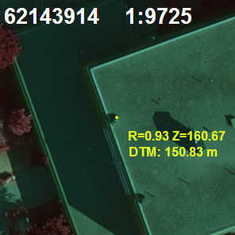
The area –based matching looks, along the epipolar line, the corresponding features in the images, and based on cross-correlation (other measures exist too), decides the solution.

2. Epipolar geometry, area-based image matching in an image triplet.

Next we will do automatic search of the corresponding image point, supported by three images.

The image in the upper left corner s.b. 3913, and next to it, 3914 in the middle and 3915 as rightmost. Now 3914 is our master image (index 1). 3913 and 3915 are the slaves (indeces 0, 2).

From the menu, select (State | Measure surface points (triplet)).

Click something in the master image, in the middle of the upper row, on the roof. Use CTRL-M to center the images to the solution.

Compare pair matching and triplet matching by using the left and the middle images as master image. You should notice that the coordinates for the “same objects” differ.

Demo – 4 Getting XYZ-coordinates almost automatically

3. Automatic matching inside an image polygon

When you are done with item 15, pan (ALT-click) the image 3913 “to the left”, until you reach a football field, where you can click the image to get the solution there and centre all images (CTRL-M).

Then using menu commands (State | Draw Polygon) and (State | Draw XY-polyline given Z), delineate a polyline in the middle image (3914), by starting with the right-mouse-click, then digitize with the left-button, and finish by clicking SHIFT-right-click.

Deactivate “draw mode” using menu commands (State | Draw Polygon) and (State | Draw XY-polyline given Z). Then click a point in the field and start image matching (Surface matching | Triple image matching).

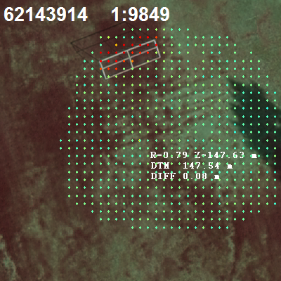
The matching is carried out in an image grid of image 3914, grid density is parameter as well as the size of the correlation window (see CTRL-O, options).

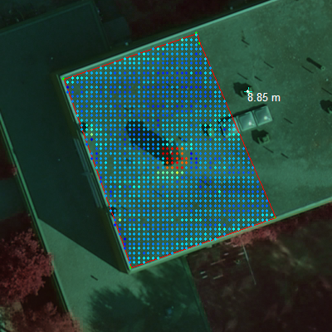
Here, the triplet matching was done in a +-3 m deep search space, and 0.5-m grid on the roof delineated by a polyline.

4 Anaglyph stereo – epipolar rectification (Optional)

If you have 3913 in the up left image position, and 3914 to the right of it; these two make a stereo pair.

(File | Create an anaglyph Stereo pair)

Set pixel size to 28 um, the rest you can just “OK”

Computing the stereo pair takes a while.

(File | Open the anaglyph Stereo Window)

(File | Open stereo pair file) – c:\data\pair.txt

Double-click the image to PAN.

“U”, “D” brings the solution up/down 1 meter.

In epipolar-resampled images the corresponding entities are on the same rows which greatly simplifies the implementation of search algorithms.

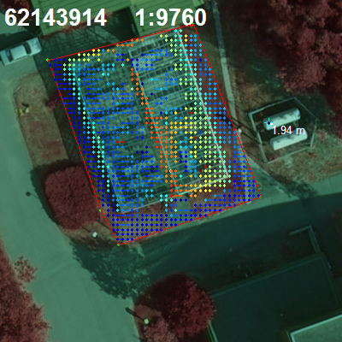
Image matching fails easily if the correspondence problem is difficult to resolve (occlusion, repeated texture). Image contains a small greenhouse.

Demo – 5 LiDAR data

Remove all images by pressing F3. Then open using F2 command c:\data\imafiles\demo1\2006_62143914.txt and c:\data\imafiles\demo1\2006_62143915.txt files. Try CTRL-Z (read DTM value) command. The ground should be at 151.09 m a.s.l. Use (File | Add TIN or Raster… | Add raster elevation model), if the ground was at -99 m.

1. Plot altm2033 data in images

First we break the control of the program (pause), by pressing CTRL-break.

CTRL-R opens the Project window. Select Form1.frm, in the code window, select the plot_als_bin_file routine. There, find the following code sequence:

Rem ********** Parameters *************
MaxDTM = 50
MinDTM = 0
DistA = 25
PlotIntensity = True
UseZNotH = False

MaxDTM and MinDTM set the range of values that is visualized in the HSV-colors. DistA is the XY radius of a plot in which the the data is superimposed. If PlotIntenity is set to False, height above ground is the theme, and if UseZNotH is true, absolute z-values are used for the theme (set range 155−162 m a.s.l.).

“F5” runs the code, then select (3D | Plot… | Plot 2004 LiDAR).

Try setting the values.

What can you say about the altm2033 intensity?

How about the XY-accuracy?
(Zoom in near the straight border of the roof)

2. Plot altm3100 data in images

Form1.frm routine Print_ALS_near_solution_Click() reads the altm3100 LiDAR data in 207 byte records and superimposes in the images. (3D | Plot | Plot 2006 LiDAR).

List 1. Struct / Type declaration of Optech’s comprehensive format (altm3100).

Rem 2006 ALTM 3100 pulse data, 207 bytes per record
Type LidarRecord
GPStime As Double
PulseCount As Byte
Returns(1 To 4) As point3D
Intensity(1 To 4) As Integer
Range(1 To 4) As Double
angle As Double
Roll As Double
Pitch As Double
Heading As Double
Poslidar As point3D
StripNum As Integer
SyncBit As Byte
Res1 As Byte
Res2 As Byte
Res3 As Byte
End Type

3. LiDAR; pulses or points?

Having the pulse geometry stored allows for using LiDAR for the measurement of scatterer-free volume. It also allows for checking the XY-accuracy of the data, if suitable linear features exist.

Click one corner of the roof, to get the XYZ-solution there.

(3D | Plot | Plot 2006-2007 LiDAR) plots the LiDAR pulses at 160.4 m a.s.l. Those that produced an echo above the elevation are drawn in red. “altm3100 points” are in dark yellow, and als50 “echoes” in light blue.
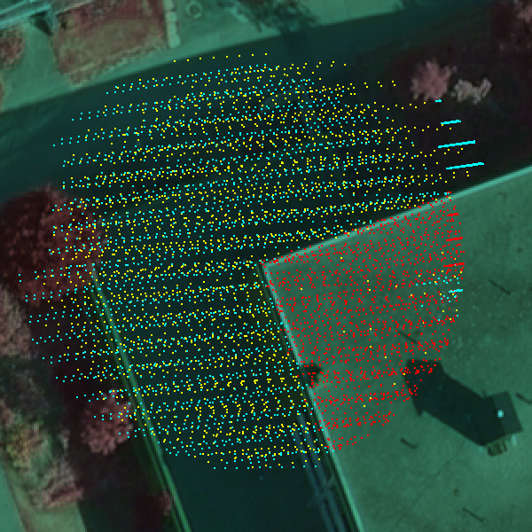
There are data from 4 overlapping strips and two sensors. The pulses are projected to the plane, Z = 160.4 and colored according to sensor and penetration of plane Z = 160.4 m.

Demo – 6 Tree measurements

1. Treetop positioning and tree height estimation with LiDAR monoplotting

You can start by removing all images (F3) and reading the image pair 3913 and 3914 with the F2-command.

PAN (Alt-click) in the images to the right to see a spruce tree (see below).

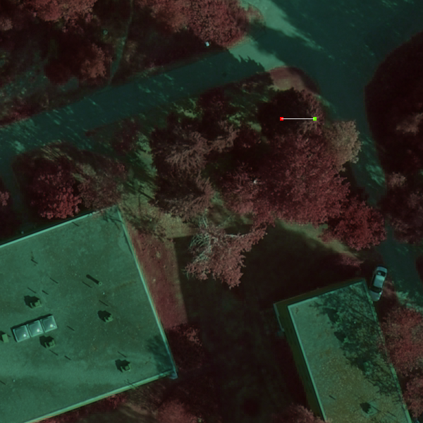

Click the top of the tree in the image, until you get ~22.50 m as the tree height.

This is the height estimate using “LiDAR-monoplotting”; where you sent a “1-m thick ray/tube” down to the scene by clicking in the image, and the first LiDAR point (2006-2008 data sets, plot by using Shift-Ins command) encountered inside the tube, was forced to intersect the ray keeping the camera-echo distance the same.

The RED dot is this solution. If you see a white dot, that is the first LiDAR echo in the “camera-ray-tube”.

If you press F12, the DTM is displayed in the screen. Tree height is simply the difference in Z.

2. Treetop position using LS ray intersection

Click the treetop (CTRL-C clears the graphics) in both images. Then CTRL-I to get the LS ray intersection solution. CTRL-Z gives the ground elevation, is the height still 22.50 m (or similar to the LiDAR-monoplotting value)?

3. Tree crown shape using non-linear regression

With the XYZ-position of the treetop, press “2” in the keyboard. That starts an iterative process where the point cloud is used for modeling the radius of the tree crown. Initial approximation is given by tree height and sp, which we assume to be P. abies, thus “2”.

The estimated crown diameter is given (Dcr: #.# m) as well as height estimates and a DBH estimate at the top of the Form1.frm window, in green text.

If you press “1”, you assume it is a pine.

Similarly, “3” is for birch / broad-leaved trees.

The DBH is estimated using species-spesific regression equations (Kallivirta and Tokola 2005),:
SQRT(DBH) = a*SQRT(H)+b*SQRT(CW)+epsilon

4. Tree crown width in image; semi-automatic template matching.

Remove all images, using the F3-command.

Read images 3913, 3914, 440303, 440304 using F2-command from c:\data\imafiles\MK\

Click in the treetop near the solution, in all images.

Press CTRL-I to solve the ray intersection.

Capture templates in images, using the CTRL-X command.

Make a series of templates over 7 scales, menu command (Image matching | Resize templates).

Activate check-Box “Multi-scale TM” on the main form.

Deactivate the epipolar lines in images (Options window, CTRL-O, Draw epipolar line…).

Click tree tops in any image to measure the Treetop position and Crown width using Template matching.

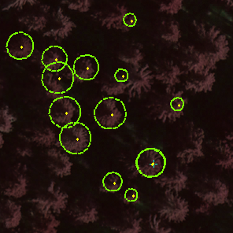
Template matching is used for 3D treetop positioning and the “best scale” gives an estimate of crown width, relative to the model tree.

/ISPRS Hannover Workshop 2007 /

5. Treetop positioning – almost automatic

Click the model tree used at the start to get the solution to get the “photo-plot” centered at that tree.

Set the plot-radius to 10 m (box with 23 as default)

Image matching | Read data for plotcenter
| Capture templates (not needed, done)
| Compute correlation images (CTRL-Y)
| Create XYZ point set (CTRL-N)
| Find Clusters (CTRL-W)

Adjust parameters XY (1.5) and Rl (0.3), and re-run the clustering step (CTRL-W).

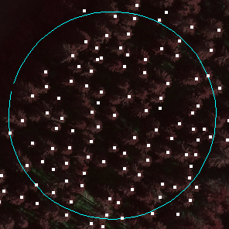
Proper selection of correlation value (Rl) and minimum distance between treetops (XY) resulted in a reasonable treetop detection results.

/Silva Fennica monographs 3, 2004/

4 Lab 2 – RADIOMETRIC ISSUES

Demo 1 – the image data for XYZ point

The 3D point could be for example e.g. a LiDAR return or a point on the surface of a crown model.

We need a mapping from the XYZ object space to the xyz-space of the camera. In camera, z = ± c, i.e. the focal length, and xy-plane corresponds to the film/focal/ccd plane. The origin is in the center, and KUVAMITT assumes that the xy-system is right-handed.
In a film-image the extent of the xy-plane is typically 23x23 cm.
UltraCAM D has a virtual “3.3 x 5.2-cm film-plane”, actually there are 8 CCDs. Some are 24 mm x 36 mm, in size.

ADS40 has CCD-lines with 12000, 6.5-um pixels, which constitutes a 7.8-cm line of pixels; all 11 lines are on the same focal plane.

First we solve the xy-coordinates of the point.
Look for MODULE1.BAS and routine
Public Sub r_transform_ground_to_pixel

Inside it, find the routine Call a_transform_affine
Click the marginal to the left, to activate this line, it turns red. The debugger will now stop on this line.

Then start Visual Basic, F5, and read an image using the F2
(Take c:\data\imafiles\demo1\2006_62143914.txt)

When the debugger stops at the line, place the cursor on top of variables camera_x and camera_y. The values are meters, in the xy-system.

Then, click on the marginal to activate debugger on the next line that has the End Sub –statement.

Continue the execution with F5-command (Continue).

Then look at the values of variables p_x and p_y by placing the cursor on top of them. These values correspond to column, row position in the image. They are decimal values, that need to be converted into a pixel, or the pixels in the vicinity are interpolated.
NOTE: In KUVAMITT, the origin (0,0) of the image coordinate system is in the low left corner of the image, and in the center of the pixel, the value is always (#.5, #.5). There exists no standards on the definition of the origin.

Demo 2 – the 16-bit R, G, B, NIR -values

The monoplotting procedure has some code for the retrieval of the pixel data for the XYZ-point that has been solved (Demo 6/1).

Pause the program (CTRL-break) and look at Module1.bas, and routine Cast_Image_ray_and_Find_Closest_LiDAR;

Find the code segment (use CTRL-F)
Rem RGBNIR-VALUES
GoTo PassBy

Write “Rem” or “’” in front of the GOTO statement.

Then run the code F5 and click targets in the image 3914.

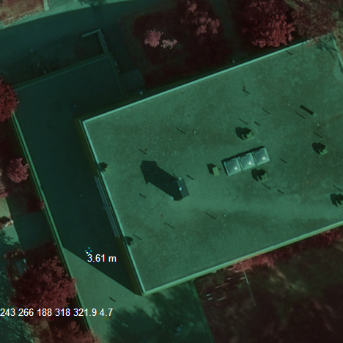
The R G B NIR Pan_Mean and PAN_SD values are printed in the image.

Try different targets.

Demo 3 – PAN-sharpened vs. original

Remove all images (F3).

Open using F2 command:
c:\data\imafiles\demo1\2006_62143914.txt

Open using CTRL-D command:
c:\data\hdr\62143914_uint8.hdr

This image has the 28.125 um (actually 9 um) pixels in NIR R and G bands; transformed from 16 to 8 bits.

The PAN-sharpening ratio of UCD is 1:3.2.

Try getiing the 16-bit pixel values, at times they are not the same, because of minor orientation differences and interpolation errors.

Demo 4 – Collecting LiDAR intensities

Pause the project using CTRL-Break. Look for procedure Match_Local_Crown() in Form1.frm.

Look for the code below:
GoTo PassBy
Form1.Picture1(0).CurrentX = 10
Form1.Picture1(0).CurrentY = 10

Make the GOTO statement into a remark by adding Rem at the start.

Run the code (F5), find a tree top and measure it using the LiDAR monoplotting technique. Then model the crown envelope by pressing either “1”, “2”, or “3” (Pine, Spruce, Other).

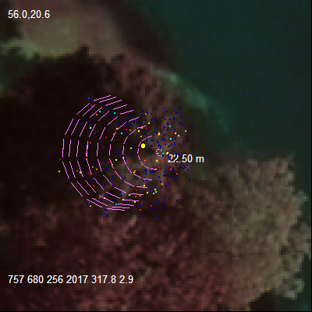
Mean intensity and SD of intensity are given in the upper left corner. Only first-return data is used.

C:\data\intensities.txt has all the observations. Given are distance down the top (m) and intensity (DN). Two sensors, als50 and altm3100 are used together.

5 Some KUVAMITT commands:

EDITING OBSERVATIONS

CTRL-A
Deletes all image observations and clears images
CTRL-C
Clears the images

MOVING AROUND

CTRL-M
Centers images to XYZ solution (variables X_sol, Y_sol, Z_sol)
Alt-Click
PAN an image
Ctrl-Click
Zoom out an image
Shift-Click
Zoom in an image
Click
Sets the image, xy-observation for an image (displayed in text boxes)

3D POSITIONING

CTRL-I
Computes least square ray intersection based on the image observations
CTRL-Z
Check the raster DEM elevation (Z) for the current XYZ-solution
F12
Plots the DEM in the images over certain area, in HSV-colors.

READING IMAGES

F2
Inserts an image to a specified XYZ-position.
F3
Removes one or all images from the display
F8
Compute images in which the XYZ-solution is visible.
CTRL-D
Reading an image (HDR-file)

PLOTTING LIDAR

Shift-ins
Plots 3 sets of LiDAR points (altm3100, 2006, 1km) (als50, 2007, 1km) (als50, 2008, 1, 2, 3 4km) in the images

