Hyytiälä Excursion Monday Sept 14, 2009

Ilkka Korpela, UH
Antti Uotila, UH/Hyytiälä
Silja Pirttijärvi, UH/Hyytiälä
Timo Tokola, UJ
Sanna Härkönen, UJ/Metla
Hans-Ole Ørka, UMB, Norway
Aarne Hovi & Pauliina Kulha, the field team.

Program 2
Hyytiälä RS-experiment in a nutshell 4
Hyytiälä – “PIHA TREES” - Promenade 6
FIELD EXCURSION 1 Lapinkangas Plot LK1 7
2 Lapinkangas Plot LK2 10
3 Plot Lapinkangas 3, LK 1 13
4 MARV1-08-Plot3 15
5 Texas – pine – spruce plot 19
6 MA1 Pine plots 1−6, thinning experiment 22
7 Marv1-2008-Plot1 25

Program

Sunday

Arriving to Hyytiälä
Accommodation in B-building. Door key-code ####. tel. +358-400-218305

Monday

07:00 Breakfast, A-building

08:15 Indoor presentations, 20 mins

Ilkka Hyytiälä RS experiment 1994-2009
Antti Forest station’s viewpoint
Hans Ole Ongoing and future research, links to Hyytiälä,
Timo “
Sanna “
Field team Field measurements in 2009

10:30 Memorial birch stand. Experiencing the measurements
“Measurement principle of tree/stand variables”
“Triangulation−trilateriation in tree positioning”
“Orientation with a LiDAR intensity map”

11:00 Lunch, Takeaway Coffee in thermos
11:45 Departure for field plot excursion;

Lapinkangas-delta: barren pine sites and understory mapping

Plots LK1 and LK2
LiDAR intensity data and tree growth
Radial/diameter increment measurements

Plot LK3
Understory mapping
LiDAR for the task?
120-yr-old Marv1-08-Plot3 (Coffee break)
Large plots vs. small plots?
Will the over 100-year-old stand disappear in Hyytiälä?
Broadleaved species in LiDAR
Texas pine-spruce plot
Intensity Signal in pine and spruce admixture

50-yr-old pine plots 1-4
Radial increment by bore cores vs. difference measurements
Treatment of the thinning experiments - agreeing
Marv1-08-Plot1
Fully measured plot, how to take maximal use of
LAI-data
15:30 “Brainstorming discussions”, extending the excursion.

16:00 Antti & Silja leave us.

“Pre-sauna jogging excursion thru the forests”

18:00 Sauna & Cabinet dinner. Timo brings some wine.

Tuesday

07:00-08:00; Breakfast. Leaving for home

Hyytiälä RS-experiment in a nutshell

Mostly on public land (Metsähallitus, MH). Hyytiälä is our spokesman towards MH. Some direct contacts with MH were made to support LiDAR campaigns 2004-2007. In 1990s MH would finance field work too. Nowadays MH can provide with project-based funding. Agreement between UH and MH exists and sets the framework.

Field plots

Hyytiälä has been around since 1910. However, the oldest permanent plots are only since 1975. Positioning of trees started in 1995. That was needed since the painting (1993-94) of the trees did not quite work out. Before 1995, forester training was not research-oriented, which it is now (and 50% of funding is external).
The station is limited in its resources to maintain (measure and manage) a large set of field plots, that would serve multiple needs. Thus researchers mostly seek “temporary help” in Hyytiälä (temporary or short term experiments). Since 1994 (1997-), I’ve tried to help in maintaining a set of permanent plots in the vicinity of the field station, in an area of 2 x 6 km.

Aims:

- Representative with respect to species admixture, site type, silviculture, age
- Co-use: “Researcher A is followed by B making it possible for C”, visibility
- Trees accurately positioned to allow monitoring (< 20 cm XY)
- If possible, the 1.3-m level is marked in trees
- Also some seedlings stands (2006, 2007)
- Even bare ground points for DEM analysis
- Paid mostly by research funds but also by MH. Hyytiälä has been supportive.
- Some 16000+5000 in over 20-yr-old trees are currently in the “database”.
- Oldest tree measurements from 2006.

The costs of establishing plots with tacheometer and measuring dbh, h, hc are 4-5€/tree.
The costs of establishing plots with photo-geodetic method + dbh, h, hc are 2-3€/tree, with 80 trees day incl. preparatory work. A dayscosts roughly 200€.

SMEAR II & FGI WX station

- SMEAR since 1995, FGI WX since 1940s.
- Profiles 0-70 m AGL (temperature, humidity, wind), short interval data
- Spectroradiometer (incoming spectrum)
- PAR, UVA, UVB, etc. also within pine canopy
- Ceilometer (LiDAR) for cloud heights
- AERONET Sun photometer (NASA)

Aerial photography

- For teaching and research has active since 1984 in Hyytiälä (Poso et al.)
- Different scales available (flying heights
- Both WA-, NA- lenses (during film era)
- All market leading digital cameras (2007-2009)
- 2008-2009, in co-op with FGI, in situ measurements and auxiliary data
- 1985 1:10000, 1:20000, 1:30000 CIR and PAN-IR
- 1989, 1992, 1995, 1997, 2002, 2004, 2006, 2009 10-cm resolution data
- First digital camera images in 2006
- Only place in Scandinavia with UltraCAM, DMC and ADS40 images
- Satellite images exist too (thru VALERI), I’m not familiar.
- All images are in the same XYZ-system with the trees (exterior orientation)
- Paid by research funds or by co-op with companies operating cameras.
- Images (history) available since 1946. All images with scale 1:30000 or smaller.

LiDAR campaigns

- Designed to cover the 2 x 6 km AOI.
- In 2004, for DEM generation, altm1233 (2-returns), 1-3 pulses/m2, 1-km flight.
- In 2006-2007, for STRS-research and sensor comparison. ALTM31000 and ALS50-II flights. 1 km, 6-8 pulses per m2. 1-4 returns per pulse –systems.
- In 2008, for area-based approach and DEM generation, ALS50-II flights at 1, 2, 3 and 4 km. 0.2 – 1.5 pulses per m2. In conjunction with an ads40-flight. Extends the area.

Future needs

- Intermediate felling in some of the plots needed to maintain an experiment in the degree of thinning (level); Plots P1, P2, P3, P6, B1, B3, B4, S1, S2, S3, S4, S5, S6. Manual thinning, logs hauled by ?
- Full waveform LiDAR campaign; not tested thus far in Scandinavia, benchmarking DR results. Expensive, 13000€ + VAT. Trying to find a consortium to do it in 2010.
- “Permanent” intensity tarps, 5%, 15%, 25%, 40%, 70%? These would be installed by the personnel during a flight.
- Better use of the NASA and SMEAR instruments / observations.
- Putting the data in one database and omitting the current by plots and campaigns -file structure.
- More data in 15-30-yr-old stands.
- A proper DEM needs to be generated using the full set of LiDAR points 2004-2008. Currently the DEM is badly erroneous in some places (Terrascan) as we did not know how to manually edit and influence the process in 2005.

Hyytiälä – “PIHA TREES” - Promenade

Needed maps (4)

http://www.helsinki.fi/~korpela/MARV1_2009/Koeala_5/LiDAR_IntensiteettiKartta_Maaosumat.pdf

http://www.helsinki.fi/~korpela/MARV1_2009/Koeala_5/LiDAR_IntensiteettiKartta.pdf

http://www.helsinki.fi/~korpela/MARV1_2009/Koeala_5/LiDAR_Korkeuskartta.pdf

http://www.helsinki.fi/~korpela/MARV1_2008/Maps_And_Labels/A3_10_kpl_Plot5_LiDAR_Intensities_H_Over_5m.pdf

LiDAR intensity measures backscatter (amplitude) of coherent light. It is affected by target reflectance, incidence angles, used power, power density, receiver settings etc. Intensity is just a DN-value and comparing two data sets requires normalization.

FIELD EXCURSION 1 Lapinkangas Plot LK1

Site type CT/VT , sandy soil, glacial delta, 50 x 50.
Late age thinning, thus differs from LK2
Age ~100 a , Volume 142 m3/ha, In 2007 some trees cut by the sewer.
Measured 2002 (d13, h, hc, dcrm-sample N=21) and 2009 (d13, h, hc, ir5a)

Fig 1. Radial increment × adjusted crown length shows moderate correlation in these old trees.
Fig 2. Relative radial increment × adjusted crown length shows no correlation in these old trees.

Fig 2. LiDAR intensity (comb_fo_u1_mean_IFus) × ig shows moderate correlation. The intensity (backscatter reflectane) being reduced for the fastest growing trees in LK1.

Table 1. Trees with the lowest and highest mean intensity in 40-% long crowns.
Low LiDAR intensity trees |  | High LiDAR intensity trees  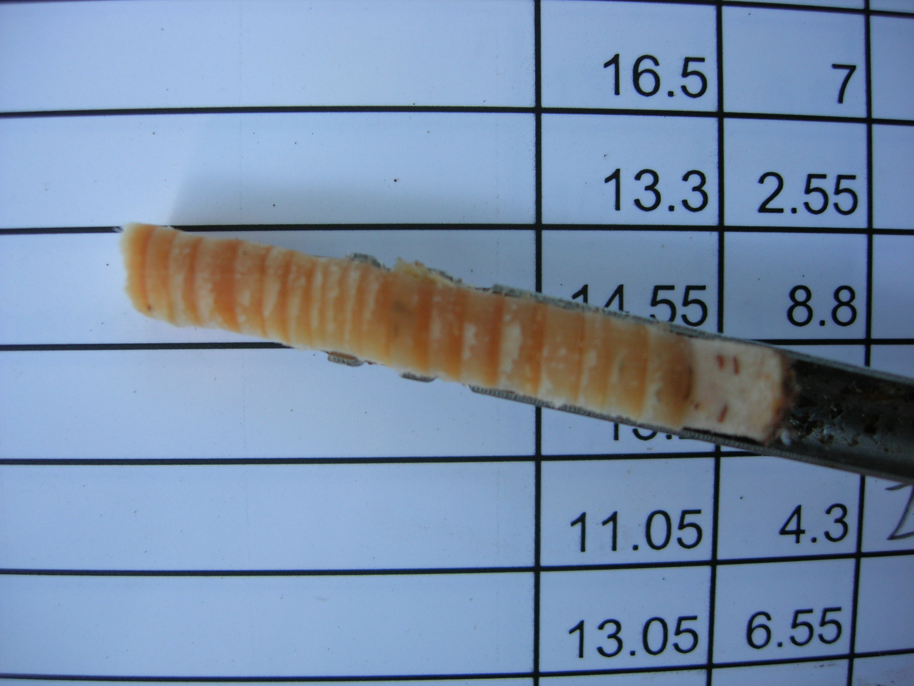  Fig 2. Bore sample. Omit 2009!
Tree | 3_fo_cr_mean_IFus | Tree | 3_fo_cr_mean_IFus
44 | 33.6 | 51 | 53.9
4 | 35 | 35 | 50.1
18 | 36.8 | 32 | 49.7
56 | 37.2 | 31 | 49.5
83 | 38.3 | 62 | 48.8
10 | 39 | 69 | 48.8
68 | 39.1 | 23 | 48.5
76 | 39.1 | 1 | 48.1
57 | 39.5 | 72 | 48
63 | 39.5 | 14 | 47.8
20 | 39.6 | 7 | 47.5
Table 2. Trees with the lowest and highest mean intensity in the top 10%.
Low LiDAR intensity treetop |  | High LiDAR intensity treetop
Tree | 3_fo_u1_mean_IFus | Tree | 3_fo_u1_mean_IFus
33 | 35.4 | 51 | 64.8
4 | 42.5 | 19 | 63.4
68 | 42.7 | 31 | 63.3
52 | 43.2 | 32 | 61.7
24 | 43.5 | 12 | 61.6
44 | 43.7 | 35 | 61.1
77 | 45.2 | 23 | 61
20 | 48.2 | 65 | 60.8
76 | 49 | 66 | 60.2
27 | 49.1 | 86 | 60.1
71 | 49.2 | 55 | 60

Replace this page by the tree map. http://www.helsinki.fi/~korpela/HYDE_2009/Lapinkangas1/LK1_PuuKartta.pdf

2 Lapinkangas Plot LK2

Site type CT/VT, sandy soil, glacial delta, 50 x 50 m.
Light thinning
Age ~100 a, Volume 229 m3/ha,
Measured 2002 (d13, h, hc, dcrm-sample N=21) and 2009 (d13, h, hc, ir5a)

Fig. 3. The correlation between id (2002-2009) using d13 differences and id(2004-2008) in the bore core sample.

Fig. 4. Trees with high radial increment (cm2) show least variation in LiDAR intensity.

Fig. 5. The median LiDAR intensity (2006, 2007) is higher for the trees that have grown best in 2004-2008.

Table 3. Trees with highest and lowest median intensity.
Tree | d5_Ifus | Tree | d5_Ifus
59 | 12.8 | 44 | 57
66 | 26.4 | 73 | 54.6
108 | 28.5 | 32 | 54.1
60 | 28.8 | 40 | 53.8
34 | 30.1 | 71 | 53.8
61 | 30.4 | 70 | 53.7
13 | 31.6 | 47 | 53.5
88 | 32.5 | 31 | 53.3
90 | 36.3 | 9 | 53
53 | 36.6 | 30 | 53

Fig. 6. (dcrm^2 x crown length) is correlated with ig. Crown width, dcrm” is measured in LiDAR.
Replace this page by the tree map. http://www.helsinki.fi/~korpela/HYDE_2009/Lapinkangas2/LK2_PuuKartta.pdf

3 Plot Lapinkangas 3, LK 1
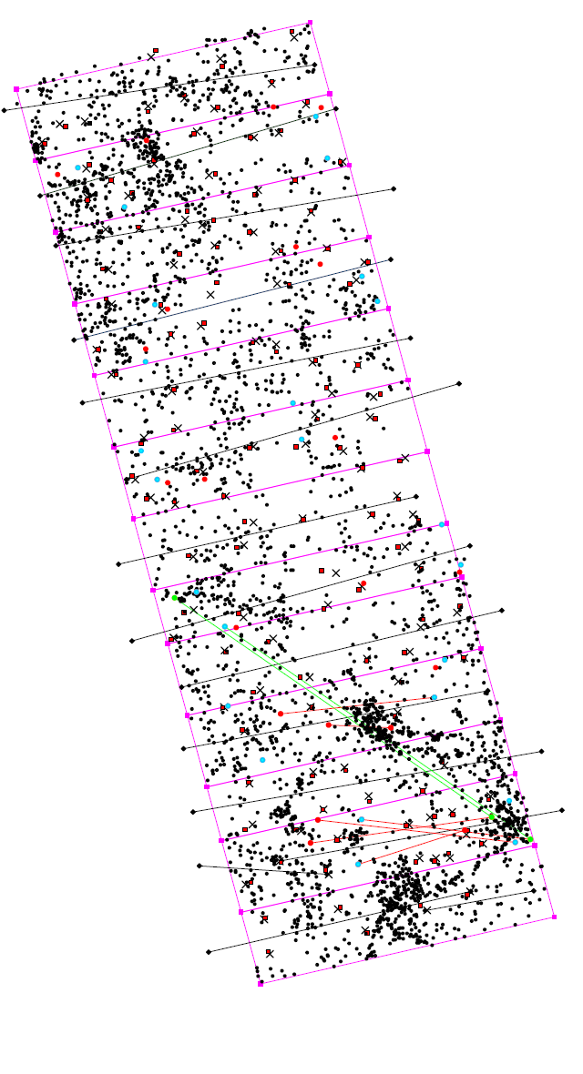
Purpose is to examine what the LIDAR signal sees in the understory vegetation. Hence, the large and understory trees were all positioned. Large trees in aerial images and LiDAR (0.3 m XY accuracy for the stems) and the understory trees were mapped along 3D lines that were established in the field. The end points of the 3D lines were positioned using trilateration and triangulation, 8 distance and azimuth observations. Z was taken from a LiDAR DEM. Estimated accuracy of the end points was 12-15 cm assuming that the measurement imprecision was 1 degree for the azimuth, 5 cm for the distances and 30 cm for the XY-coordinates of the control points, i.e. the large trees. The latter was verified by taking control measurements of intertree distances.

The XY errors are small, 3-4 cm inside 6-8-m-wide strips, but 10-15 cm between strips.

The adjustment (regression) will be improved by using all of the photo-trees that were inside the mapped area, 30 ±5 m × 100 m. These trees were all “mapped” together with the understory trees. Thus more than 8 distance observations are available.
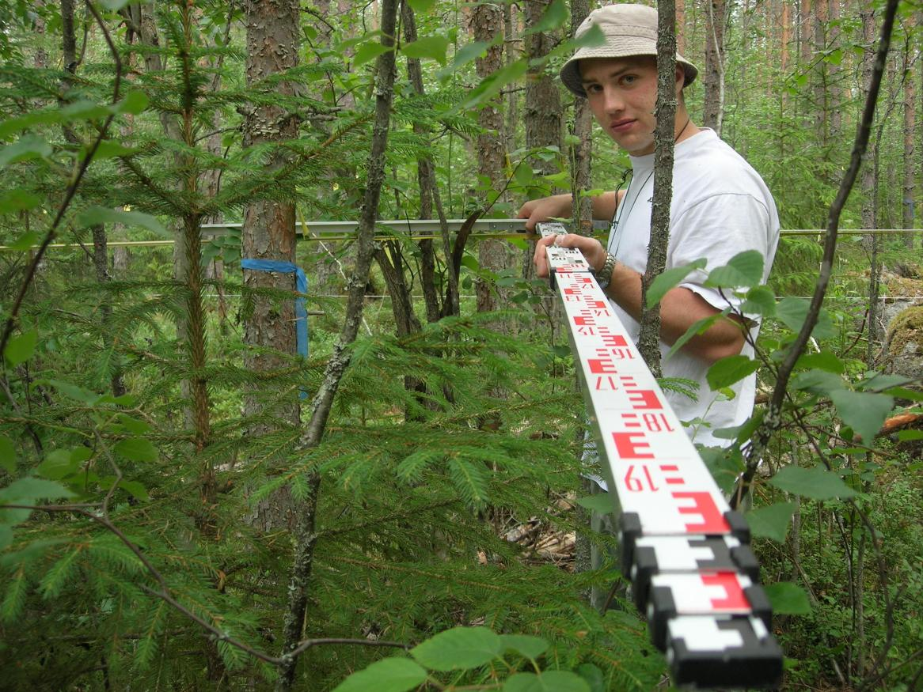
Fig 7. Map of strips, 3D vectors and distance-vectors that were used for analysizing the accuracies.
Fig 8. The actual mapping was done by observing two distances, one along the 3D vector (a measuring tape was attached to a tight 3-mm wire) and the second perpendicular to the wire. A L-tool was built for the task.

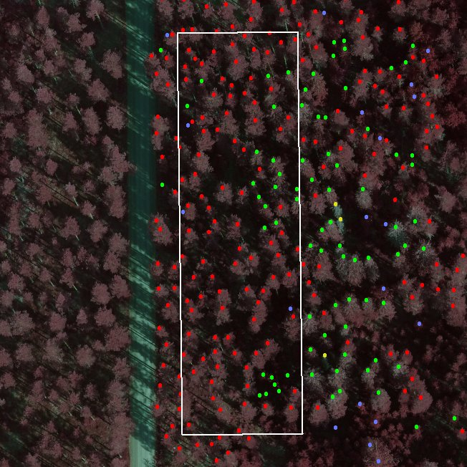
Fig 9. LK3 as seen in an aerial view Borders are drawn at the approximate elevation of the ground (DEM) and the dots depict tree tops. Colors give the species.

4 MARV1-08-Plot3

In 2007−2009, the field work was largely done by 1st & 2nd year students on “marv” courses, thus the name indicating course-year-plot. Because of the supervision, the plots form clusters, here 4 × 50 m × 50 m. After double measurements, the quality was found to be mostly good. Tree positioning has built-in error control because it is done with the triangulation method.

The speed is roughly 80-100 photo-trees per day per person, which includes labeling, tallying, d13, h and hc -measurements. The trilateration speed is approximately 100 trees per day per person, when 4 distance or azimuth observations are taken.

Table 4. mean intensity of crown echoes, first-or-only data. h > 20 m.
Dead, standing trees |  |  | Highest intensity (top ten) |  |  | Lowest intensity (top ten)
Tree | Sp_text | mean  IFus | Tree | Sp_text | mean  IFus | Tree | Sp_text | mean  IFus
B214 | PINUSSYL | 23.3 | C367 | PICABIES | 70.6 | B101 | BETPEND | 33
A84 | PICABIES | 23.7 | D401 | PICABIES | 62.9 | A12 | BETPEND | 34.4
C322 | PINUSSYL | 24.1 | C316 | PICABIES | 62 | C338 | PICABIES | 35
D423 | PICABIES | 24.7 | D376 | PICABIES | 60.8 | C340 | PINUSSYL | 36.7
A2 | PICABIES | 24.9 | D497 | PICABIES | 59.8 | C252 | PINUSSYL | 37.2
D410 | PICABIES | 35.6 | A73 | PICABIES | 59.5 | B230 | PINUSSYL | 37.4
B712 | PINUSSYL | 38.1 | D404 | PICABIES | 59.2 | B220 | PINUSSYL | 37.6
D420 | PICABIES | 38.8 | C250 | PICABIES | 58.9 | B197 | PINUSSYL | 38
C253 | PICABIES | 42 | D392 | PICABIES | 58.6 | A86 | BETPEND | 38.3

Table 5. All birch trees with h > 18 m.
Tree | Sp_text | mean_IFus | sdev_IFus
B225 | BETPUB | 67.5 | 21.8
B144 | BETPUB | 58.7 | 20.2
A46 | BETPEND | 53 | 21
C245 | BETPEND | 50.1 | 21.9
A21 | BETPEND | 49.1 | 24.3
A19 | BETPEND | 46.6 | 20.8
B216 | BETPUB | 42.4 | 18.8
A81 | BETPEND | 39.9 | 21
C702 | BETPUB | 39.8 | 20
A86 | BETPEND | 38.3 | 21.3
A12 | BETPEND | 34.4 | 20.3
B101 | BETPEND | 33 | 16.9

Replace this page by the tree map.
http://www.helsinki.fi/~korpela/MARV1_2008/Maps_And_Labels/A3_10_kpl_Plot3_Map.pdf
Replace this page by the map showing LiDAR intensity data points | h > 5 m.
http://www.helsinki.fi/~korpela/MARV1_2008/Maps_And_Labels/A3_5_kpl_Plot4_LiDAR_Intensities_H_Over_5m.pdf
Replace this page by the map showing LiDAR intensity data points | h < 1 m.
http://www.helsinki.fi/~korpela/MARV1_2008/Maps_And_Labels/A3_5_kpl_Plot3_LiDAR_Intensities_H_Below_1m.pdf

5 Texas – pine – spruce plot

Last plots that was mapped with the tacheometer -technique in 2005. One of the oldest artificial regeneration (clear cut) areas in Hyytiälä, from late 1940s.

2005: h/hc was measured in all trees
2007: Some trees by the road were felled
2009: h was measured in every third tree with hrel>0.5. hc/ir was measured in all trees
with hrel>0.5. Control measurements taken to study measurement precision.

Table 6. Differences of double measurements, N=19. Precision is SD/SQRT(2).
 | variable
 | d1.3 (mm) | h (m) | hc (m)
Mean | -0.7 | -0.02 | -0.01
SD | 2.3 | 0.30 | 0.85

Fig 10. (h-hc)*hrel x ig.

Fig 11. Increment in basal area x mean intensity of crown points.

Fig 12. Increment in basal area x 9the decile.

Table 7. Pines according the the 9th intensity decile, low and high values.
Tree | Sp_text | d9_Ifus | Tree | Sp_text | d9_Ifus
294 | PINUSSYL | 48.9 | 196 | PINUSSYL | 70.3
177 | PINUSSYL | 49.2 | 180 | PINUSSYL | 68.3
400 | PINUSSYL | 50.8 | 124 | PINUSSYL | 68.2
272 | PINUSSYL | 51.1 | 281 | PINUSSYL | 68.1
47 | PINUSSYL | 51.6 | 350 | PINUSSYL | 67.8
244 | PINUSSYL | 52 | 144 | PINUSSYL | 67.2
43 | PINUSSYL | 52.1 | 398 | PINUSSYL | 67.2
421 | PINUSSYL | 52.4 | 171 | PINUSSYL | 67.1
172 | PINUSSYL | 53.5 | 139 | PINUSSYL | 66.9
Replace this page with the tree map.
http://www.helsinki.fi/~korpela/HYDE_2009/Texas/Texas_PuuKartta.pdf

6 MA1 Pine plots 1−6, thinning experiment

- 2002 dbh, h, hc in all trees
- 2009 dbh/tallying in all trees, h/hc in subplots giving 50 large trees

Fig 12 . Correlation of increment measurements by difference and bore core.

Fig 13. Crown length x ig.
Fig 14. Pines Basal area increment x mean intensity.

Fig 14. Pines Basal area increment x SD intensity.

Replace this page with the tree map.
http://www.helsinki.fi/~korpela/HYDE_2009/MA1/MA1_PuuKartta.pdf

7 Marv1-2008-Plot1
This plot, 60 x 60 m, was measured in 2008 for dbh, h and hc by students & JV.
2009: understorey, h/hc (50%) and ir in all trees. LAI-measurements.
Gradient in site type and understory.
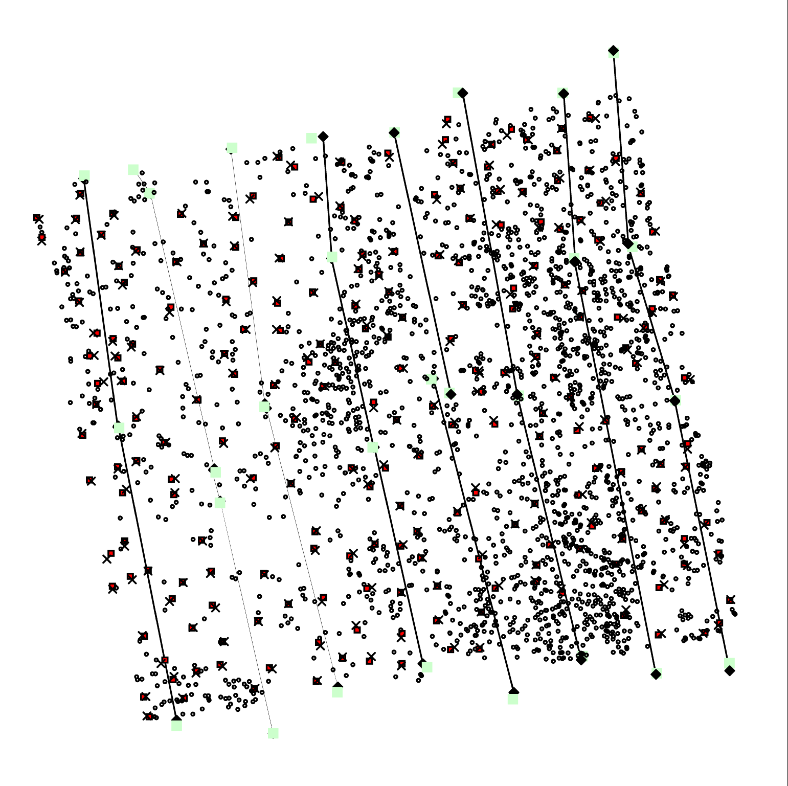
Fig 15. Tree map with 2069 understorey trees. The boxes and crosses denote photo-tree positions measured in the LiDAR and in the field, respectively. The line segments denote the 3D vectors used for the positioning of the understorey.

Table 8. Differences in 226 photo-trees mapped during the work.
 | Δx | Δy
mean | -0.02 | 0.00
SD | 0.20 | 0.24
Fig 16. basal area increment and mean intensity.
Fig. 17. Skewness of the per-tree intensity distribution. Positive means that there are individual high values, negative means that the extremes are rather of low intensity.
Fig. 18. Density decile measure the proportion of points from the top to the height that is 0.8 from the top, 1.0 is the height of the lowest LiDAR crown hit.
Fig. 19. Basl area increment x height decile 7. hd7==0.1 means that 70% of lidar points were in the top 10% of the tree. Similarly hd7==0.3 means that 70% of LIDAR points are in the uppermost 30% of the tree. hd is a measure of crown shape.

Replace this page by tree map:
http://www.helsinki.fi/~korpela/MARV1_2008/Maps_And_Labels/A3_10_kpl_Plot1_Map.pdf

Replace this page by height map:
http://www.helsinki.fi/~korpela/MARV1_2008/Maps_And_Labels/A3_5_kpl_Plot1_LiDAR_Point_Heights_Over_5m.pdf

Replace this page by intensity map of trees:
http://www.helsinki.fi/~korpela/MARV1_2008/Maps_And_Labels/A3_5_kpl_Plot1_LiDAR_Intensities_H_Over_5m.pdf

Replace this page by intensity map of understorey:
http://www.helsinki.fi/~korpela/MARV1_2008/Maps_And_Labels/A3_5_kpl_Plot1_LiDAR_Intensities_H_Between_1m_5m.pdf

