NatureGate® R& D and business program – a general description and a proposal for Sweden
by
Prof. Mauri Åhlberg (University of Helsinki), producer Eija Lehmuskallio, and
photographer Jouko Lehmuskallio

Handout for the presentation in The Royal Swedish Academy of Sciences (Kungliga Vetenskapsakademien), The Swedish National Committee for Biology (Svenska Nationalkommittén för Biologi). Thursday, November 9, 2006, in the Linné Hall (Linnésalen)
Stockholm, Sweden.

A general description of NatureGate® R& D and business program

NatutureGate® R& D and business program was created in January 2006. It is based on 16 years of systematic work by Eija and Jouko Lehmuskallio. Practically all of the flowering plants and biotopes of Norden and Scandinavia have been photographed very professionally, beautifully and in scientific detail. Eija and Jouko Lehmuskallio have paid the development of the easy-to-use, fast, patented soft ware for plant species identification. The patent covers digital and mobile identification of all objects, including other organisms, rocks and minerals. NatutureGate® R& D and business program is described in more detail in Åhlberg, Lehmuskallio and Lehmuskallio (2006). We have research contacts with leading universities including Stanford and Berkeley.
The basic structure NatureGate® and the chain of reasoning are presented in the Table 1 and Fig. 1.

(1) the starting point | (2) the next level | (3) the more advanced level
photographs and videos of flowering plants, and vascular plants in general, later on all organisms. The easy-to-use, fast, patented soft ware for plant species identification. | ecosystems and their services for the whole humankind | sustainable development,  UN Decade of Education for Sustainable development  (2005 – 2014)
refers to | refers to | refers to
concrete objects | both concrete and abstract objects, real ecosystems, the biggest is biosphere itself, can be represented by  systems models,  more abstract than individual species and specimens | very abstract objects and reasoning of very complex issues and problems of the real world. Involves plenty of high quality learning, thinking, and acting for sustainability
encourage studying, investigations, and inquiries of them in nature, outdoors, e.g. taking digital photographs and uploading them to NatureGate® server. | encourage studying, investigations, and inquiries of them in nature, outdoors, e.g. taking digital photographs and creating conceptual models, and dynamic models | encourage both individual and collaborative knowledge building and acting to promote sustainable development

Table 1. Some of the main content elements of NatureGate® R&D server on three levels.

The core of NatureGate® server (Figure 1) will be

- exceptionally good professional photographs and videos of plants and biotopes, scientifically accurate and aesthetically enjoyable and motivating
- easy-to-use, fast, patented soft ware for identification of plants, and other organisms, later on.
- promotion of biodiversity research and education. In the first EU e-conference on biodiversity research and education, one of the conclusions was that biodiversity research and education could be probably best promoted by a network of biodiversity servers, like NatureGate® (Young, Åhlberg,, Niemelä, Parr, Pauleit & Watt (Editors). 2006.).

NatureGate®’s proposal for Sweden

One of the reasons for this presentation of NatureGate® is to discuss about the possibility of launching it for use in Sweden. Carl Linnaeus was born in May 1707. He is one of the greatest researchers in the history of biology. The next year 2007 will be his 300 years jubilee, The Linnaeus Tercentenary.

Carl Linnaeus was one of the founders of The Royal Swedish Academy of Sciences (Kungliga Vetenskapsakademien) in 1739. We have learnt that the goals of The Swedish National Committee for Biology (Svenska Nationalkommittén för Biologi) include:
• to strengthen the position of biology in society (school, the public and industry)
• to act as advisory authority for universities and other branches of the educational system.

Schools and universities probably would not have money to buy NatureGate® services. They have to be free of charge as the services of Google. There are promises that it will be financially self-supporting in long term, in the same way as Google® is. Google has shown amazing development from 2000 to 2006 (Battelle 2005, Vise & Malseed 2005). It has become from humble beginning to one of the biggest and most valuable companies in the world. Google and its rivals have transformed both business and the whole culture by the web search-activities that they created. The idea of NatureGate® is like “NatureGoogle”, a free service, which however creates plenty of added values and business opportunities for everybody, both individuals, societies, and organizations, for the whole humankind. Every main country has its own node of Google. NatureGate® has similar business plan, vision and strategy.

NatureGate® would promote also many kinds of industries, and sustainable business in general. There are nowadays millions of people having interest, time and money to travel and take digital photographs of plants and other organisms. It is the starting point. If later on, also garden plants would be included, then again millions people more would be invited to use NatureGate®. If birds or butterflies would be included, then again millions of new users would benefit of the service. All their uploaded photographs could be used for biological research and research on biology learning and education.

NatureGate® would provide life long biodiversity learning and education for everybody. Everybody would also have an opportunity to learn both more, and more deeply about, and for sustainable development, good environment and good life.

There is a Swedish program, ArtDatabanken, which could easily cooperate with NatureGate®. They are complementary, not competing programs.
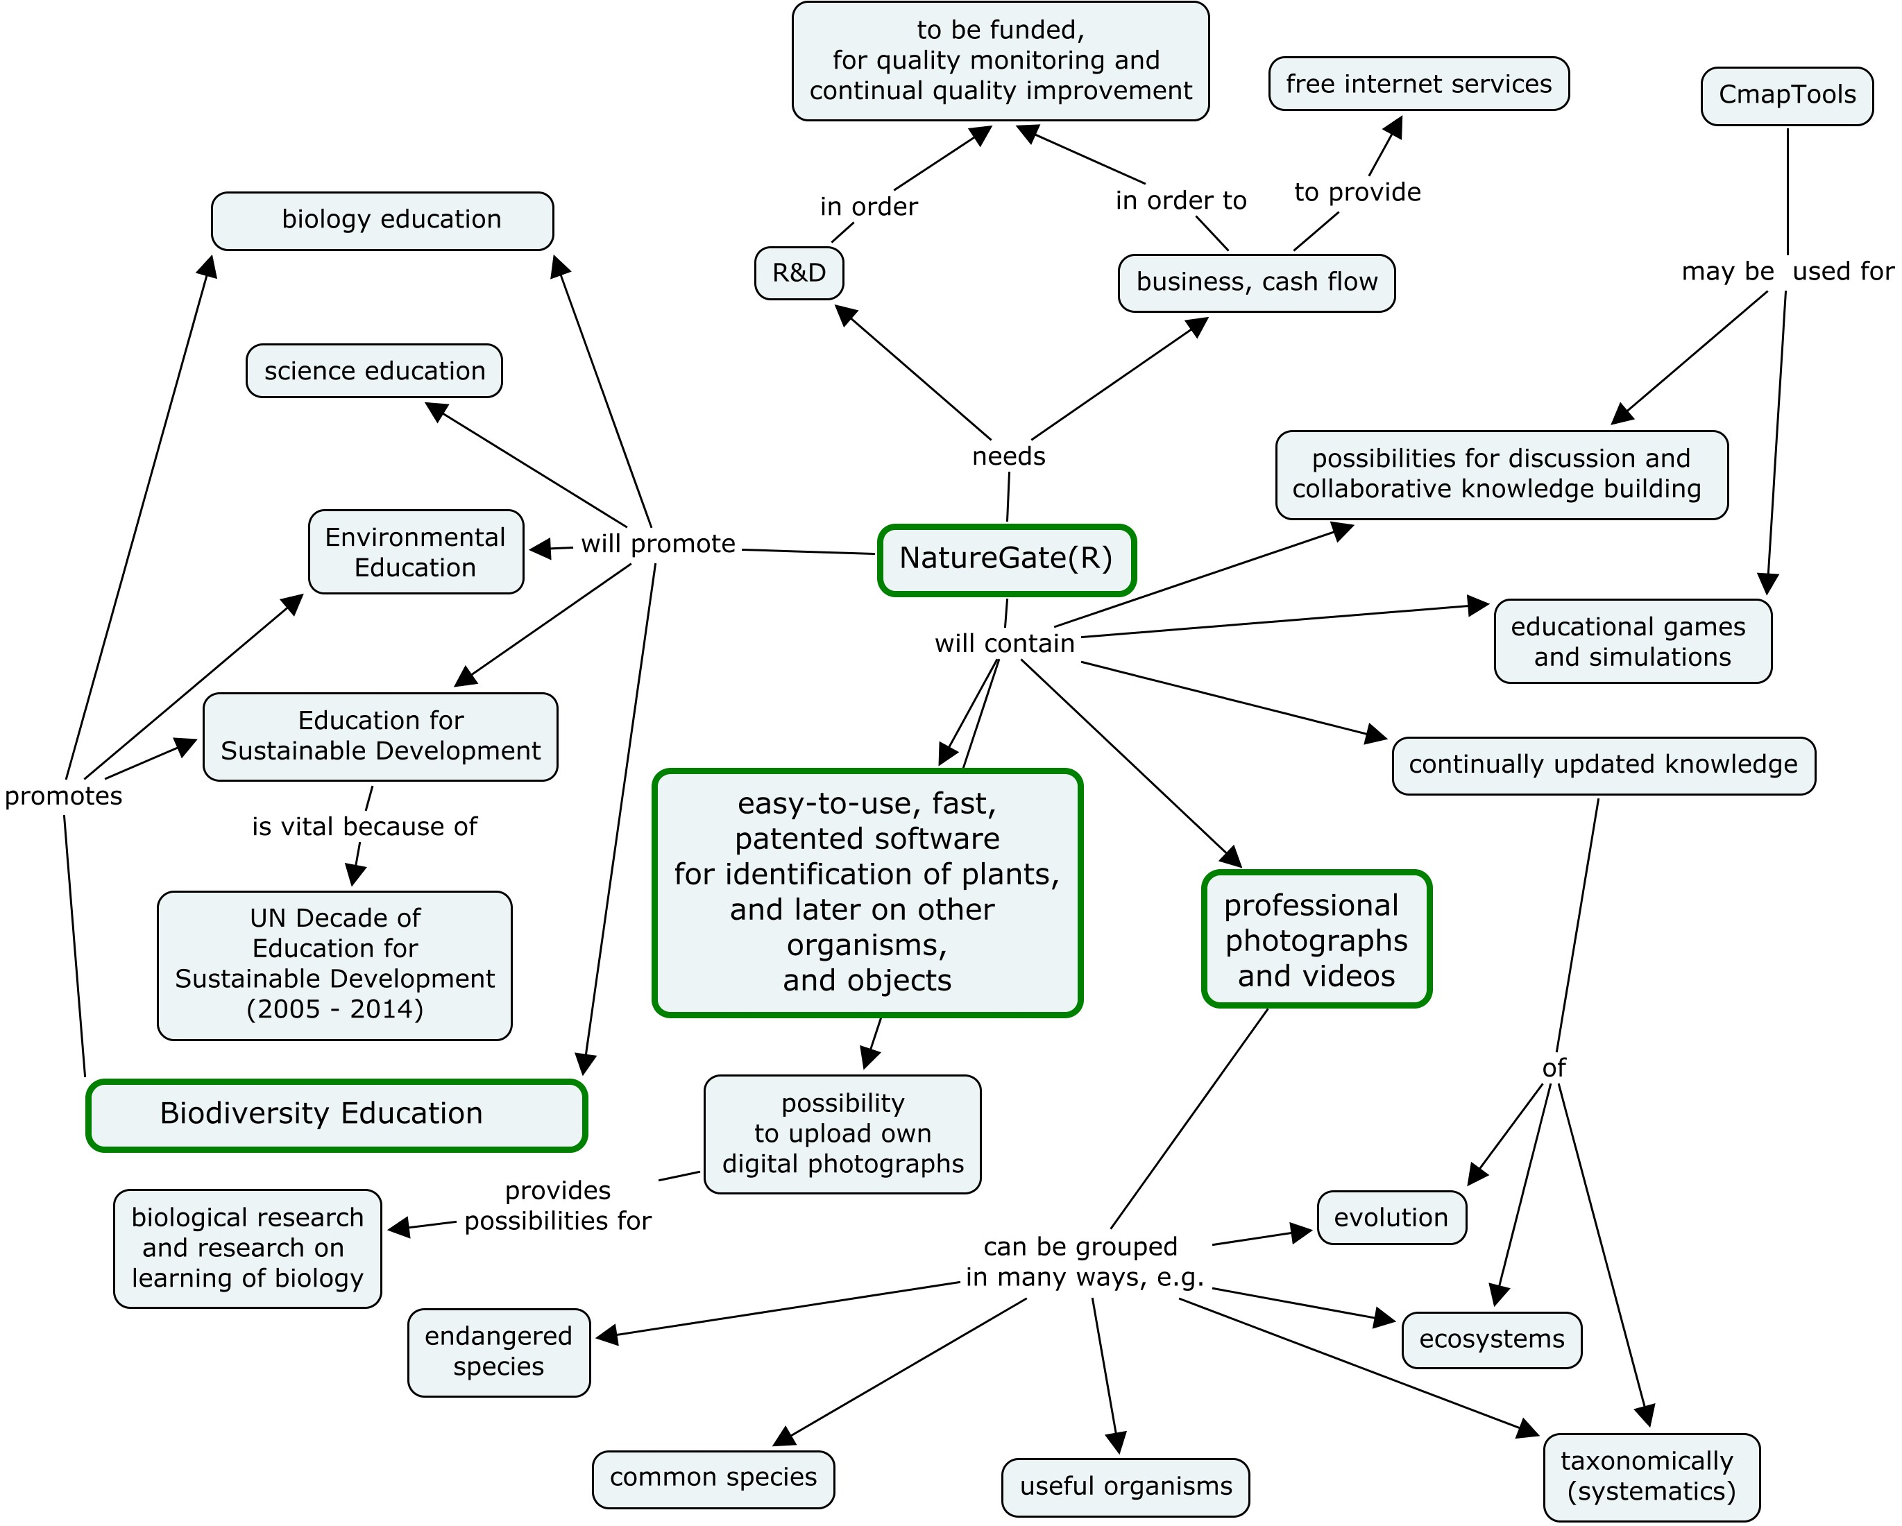

Figure 1.Main elements of NatureGate® R&D and business program in November 9, 2006. (This concept map is created by a free software, CmapTools.)

References
- Battelle, J. 2005. The search. How Google and its rivals rewrote the rules of business and transformed our culture. Boston: Nicholas Brealey Publishing.
- Vise, D. & Malseed, M. 2005. The Google story. New York: Bantam Dell.
- Young, J., Åhlberg, M., Niemelä, N., Parr, T., Pauleit, S., & Watt, A.D. (Editors). 2006. Actions for the 2010 biodiversity target in Europe – How does research contribute to halting biodiversity loss? Report of an e-conference. Helsinki: University of Helsinki. Department of Biological and Environmental Sciences.
- Åhlberg, M., Lehmuskallio, E. and Lehmuskallio, J. 2006. NatureGate®, concept mapping and CmapTools: Creating global networks of servers for improved learning about, in and for nature, ecosystems, biodiversity, and sustainable development. In Canas, A. & Novak, J. (Eds.) Concept Maps: Theory, Methodology, Technology. Proceedings of the Second International Conference on Concept Mapping. San José, Costa Rica - September 5-8, 2006. San Jose: Universidad de Costa Rica, 457 - 460,
http://cmc.ihmc.us/cmc2006Papers/cmc2006-p230.pdf#search=%22NatureGate%22

