N a t u r e G a t e®
R&D and business program in progress
Handout for the poster in the meeting of the European Platform for Biodiversity Research Strategy (EPBRS) held under the Finnish Presidency of the EU. Helsinki-Espoo, 17.-19. November 2006
Professor Mauri Åhlberg, University of Helsinki, FINLAND
(Email: mauri.ahlberg@helsinki.fi Homepage: http://www.helsinki.fi/people/mauri.ahlberg )
Producer Eija Lehmuskallio, Photographer Jouko Lehmuskallio
(Email: eija.lehmuskallio@recproductions.fi, eija@luontoportti.com )

Introduction

N a t u r e G a t e® is a social innovation in progress. It will promote biodiversity research, policy making and biodiversity education. NatureGate® is described in greater detail in the following documents: Åhlberg, Lehmuskallio and Lehmuskallio (2006a and 2006b); Young, Åhlberg, Niemelä, Parr, Pauleit & Watt (Editors) (2006). In the long term, it will be financially self-supporting in the same way as Google®. Google has shown amazing development from 2000 to 2006 (Battelle 2005, Vise & Malseed 2005). From a humble beginning Google has become one of the biggest and most valuable companies in the world. Google and its rivals have transformed both business and the whole culture by the web search-activities they created. The idea of NatureGate® is a kind of “NatureGoogle”, a free service creating plenty of added values and business opportunities for everybody from individuals to societies and organizations, for the whole humankind. There is emerging understanding in the importance of integrating interdisciplinary research and networked society, education and importance of healthy sustainable business in creating wealth for sustainable development, good environment and good life (e.g. Åhlberg 1998, Cairncross 2002 and 2006).

Biodiversity research

N a t u r e G a t e® will promote biodiversity research in many ways, e.g.;
- creating a collection/library of excellent photographs, aesthetically appealing, and scientifically accurate
- through digital photographs, uploaded by users, attached with geographic positioning, by notes and discussions of users, and by cumulative collaborative knowledge building by biodiversity experts.

Biodiversity education

Biodiversity education will benefit from NatureGate® in many ways, e.g. by having free, systematic, comprehensive, digital collections of high quality photographs and descriptions of flowering plants, and later on other organism and their biotopes, and easy to use, fast, patented software for identification of plants, and later on other organisms. (Figure 1. and Table 1.)

NatureGate® - funding

Earlier similar efforts have suffered from shortage of funding. In NatureGate® approach, public funding will be used only for starting up the main servers. NatureGate® business will integrate ecologically, economically and socially sustainable development, and it will create enough wealth for continual spreading and improvement of the networked NatureGate® servers in all the main countries and regions. This way it creates a global learning space for biodiversity research, policy making and education.

References

Åhlberg, M. 1998c. Education for sustainability, good environment and good life. In Åhlberg, M. & Leal Filho, W. (Eds.) 1998. Environmental education for sustainability: good environment, good life. Frankfurt am Main: Peter Lang, 25 - 43.

Åhlberg, M., Lehmuskallio, E. and Lehmuskallio, J. 2006a. NatureGate®, concept mapping and CmapTools: Creating global networks of servers for improved learning about, in and for nature, ecosystems, biodiversity, and sustainable development. In Canas, A. & Novak, J. (Eds.) Concept Maps: Theory, Methodology, Technology. Proceedings of the Second International Conference on Concept Mapping. San José, Costa Rica - September 5-8, 2006. San Jose: Universidad de Costa Rica, 457 - 460,
http://cmc.ihmc.us/cmc2006Papers/cmc2006-p230.pdf#search=%22NatureGate%22

Åhlberg, M., Lehmuskallio, E. and Lehmuskallio, J. 2006b.NatureGate® R& D and business program – a general description and a proposal for Sweden. Handout for the presentation in The Royal Swedish Academy of Sciences (Kungliga Vetenskapsakademien), The Swedish National Committee for Biology (Svenska Nationalkommittén för Biologi). Thursday, November 9, 2006, in the Linné Hall (Linnésalen), Stockholm, Sweden,
http://bulsa.helsinki.fi/~maahlber/Vetenskapsakademien_9.11.2006.doc

Battelle, J. 2005. The search. How Google and its rivals rewrote the rules of business and transformed our culture. Boston: Nicholas Brealey Publishing.

Cairncross, F. 2002. The Company of the Future. Boston: Harvard Business School Publishing.

Cairncross, F. 2006. People, Science and Society: the Challenge of Climate Change - The British Association for the Advancement of Science. Presidential Address to the Festival of Science in Norwich (4 September 2006),
http://www.the-ba.net/the-ba/PressOffice/PressReleases/_PresAddress06.htm

Vise, D. & Malseed, M. 2005. The Google story. New York: Bantam Dell.

Young, J., Åhlberg, M., Niemelä, N., Parr, T., Pauleit, S., & Watt, A.D. (Editors). 2006. Actions for the 2010 biodiversity target in Europe – How does research contribute to halting biodiversity loss? Report of an e-conference. Helsinki: University of Helsinki. Department of Biological and Environmental Sciences.

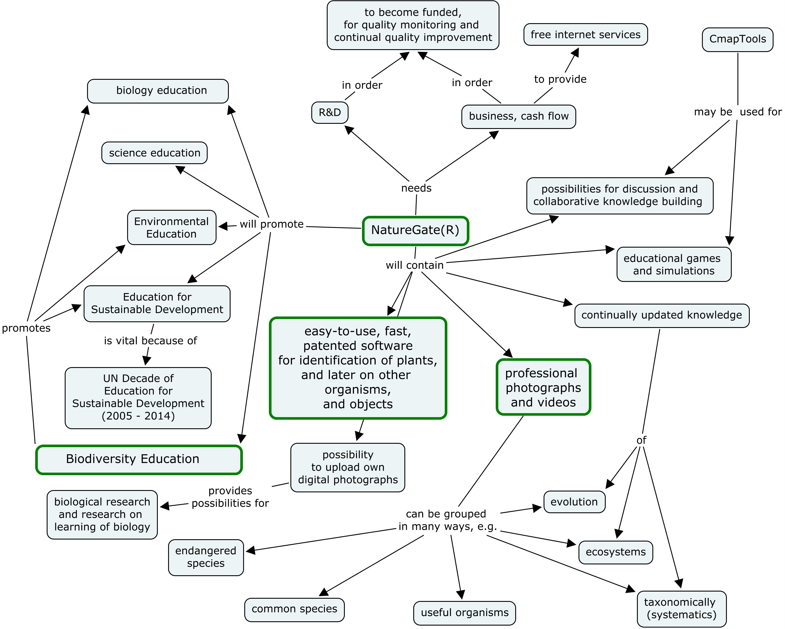

Figure 1.Main elements of NatureGate® R&D and business program in November 9, 2006. This concept map is created by a free software, CmapTools. (Adapted from Åhlberg, Lehmuskallio & Lehmuskallio 2006b.)

(1) the starting point | (2) the next level | (3) the more advanced level
photographs and videos of flowering plants, and vascular plants in general, later on, all organisms. The easy-to-use, fast, patented software for plant species identification. | ecosystems and their services for the whole humankind | sustainable development,  UN Decade of Education for Sustainable development  (2005 – 2014)
refer to | refer to | refer to
concrete objects | both concrete and abstract objects, real ecosystems, the biggest is biosphere itself, can be represented by  systems models,  more abstract than individual species and specimens | very abstract objects and reasoning of very complex issues and problems of the real world. Involves plenty of high quality learning, thinking, and acting for sustainability, including biodiversity.
in order to | in order to | in order to
encourage studying, investigations, and inquiries of them in nature, outdoors, e.g. taking digital photographs and uploading them to NatureGate® server. | encourage studying, investigations, and inquiries of them in nature, outdoors, e.g. taking digital photographs and creating conceptual models, and dynamic models | encourage both individual and collaborative knowledge building and acting to promote sustainable development, including biodiversity.

Table 1. Some of the main content elements of NatureGate® R&D server on three levels.
(Adapted from Åhlberg, Lehmuskallio and Lehmuskallio 2006b)

