Promoting biodiversity education both locally and globally
A keynote lecture on the symposium ‘Biodiverstät lernen – eine didaktische Herausforderung’.
The Österreichischen Kompetenzzentrums für Didaktik der Biologie (AECC-Bio)
at University of Vienna (Wien), Austria. April 13, 2007
Mauri Åhlberg, Eija and Jouko Lehmuskallio, University of Helsinki, FINLAND
homepage: http://www.helsinki.fi/people/mauri.ahlberg
email: mauri.ahlberg@helsinki.fi

Introduction

Biodiversity is in danger in the rapidly changing world. Biodiversity education (BE) has strong interrelationship with Environmental Education (EE) and Education for Sustainable Development (ESD). Fortunately learning processes are nowadays better understood from individual level to the level of the whole humankind. Thinking of EE and ESD, it is extremely important that the whole humankind can learn, thanks to modern Information and communication technology (ICT), in particular Internet and WWW. NatureGate® and CmapTools are presented as future options to promote BE, EE, and ESD.

Biodiversity is defined in the spirit of The United Nations Earth Summit in Rio de Janeiro (1992): the variability among living organisms within species, between species and of ecosystems. This is the definition adopted by the United Nations Convention on Biological Diversity (1992). The Convention recognizes that biological diversity is also about people and our need for food security, medicines, fresh air and water, shelter, and a clean and healthy environment in which to live. This means that biodiversity education is a part of UN Decade of Education for Sustainable Development (2005 – 2014) (UNESCO 2007). Like sustainable development biodiversity has to be monitored and promoted both locally and globally. All forests, meadows, “wastelands”, road sides, lakes, rivers, springs etc. are valuable for biodiversity education locally.

Biodiversity Education (BE)

Biodiversity Education (BE) has become increasingly important during the time of rapid biodiversity loss. The most important document concerning BE is The Convention on Biological Diversity, originally signed in Rio de Janeiro Earth Summit in 1992 (CBD, 2007):
“Signed by 150 government leaders at the 1992 Rio Earth Summit, the Convention on Biological Diversity is dedicated to promoting sustainable development. Conceived as a practical tool for translating the principles of Agenda 21 into reality, the Convention recognizes that biological diversity is about more than plants, animals and micro organisms and their ecosystems – it is about people and our need for food security, medicines, fresh air and water, shelter, and a clean and healthy environment in which to live.”

BE is both local and global, as all other aspects of sustainable development, that concerns the whole humankind, the whole biosphere. There are strong interrelationships between BE, EE and ESD.
Many organisations try to halt biodiversity loss. One of them is Conservation International which uses concept of [terrestrial] biodiversity hotspots: “The biodiversity hotspots hold especially high numbers of endemic species, yet their combined area of remaining habitat covers only 2.3 percent of the Earth's land surface. Each hotspot faces extreme threats and has already lost at least 70 percent of its original natural vegetation. Over 50 percent of the world’s plant species and 42 percent of all terrestrial vertebrate species are endemic to the 34 terrestrial biodiversity hotspots”.

We know that about 71 Percent of the Earth's surface is covered with water. We have to take care also of aquatic biodiversity. However, most people live on land and are much more familiar with terrestrial ecosystems. That is why our starting point can be terrestrial biodiversity.

European Union (EU) is one of the wealthiest and best educated parts of the world. It has both will and resources to conserve and enhance global biodiversity. It had its first e-conference on Biodiversity Education (Youth and Biodiversity) inside a broader European Platform for Biodiversity Research Strategy (EPBRS) e-conference, September 25 to October 13, 2006 (Young & al. Eds., 2006). One main question asked was as follows: What is strategically important research that should be undertaken for promoting biodiversity education and learning? The main point of the answer of the expert group was condensed as follows:
“The first research priority should be: How can the Tree of Life, or any other global network of servers, be developed into real global network of biodiversity servers promoting biodiversity learning of all humankind? If we agree that the most important issue is to activate the whole humankind, then the NatureGate type approach could be the focus of strategically important research that should be undertaken for promoting biodiversity education and learning. Connected to the global network of biodiversity servers, we need cumulative research on what people learn and think about organisms, biotopes, and ecosystems, and all other aspects of biodiversity. Digital resources, photographs, documents and videos, they attach the servers, e.g. by using CmapTools, would be extremely revealing material for future research on biodiversity conservation and
biodiversity education and learning.” There are important concepts of NatureGate and CmapTools which will be discussed later on in this article.

Global and local biodiversity

Importance of global biodiversity education can be understood by the following examples.

- Tree of Life (2007) is a web project, http://www.tolweb.org/tree/ . It began 1995. It is funded by the U. S. National Science Foundation and the University of Arizona. Its development has been very slow, probably because of lack of funding.
- Diversity of life (2007) has also a web project, http://132.236.163.182/ . Its history is not told on the site. It development has been very slow, because of lack of funding.
- Conservation International (2007a) is a charity which is asking continually donations. It has a modest photo galleries, http://www.conservation.org/xp/CIWEB/library/photogalleries.xml
- All Species Foundation (2007) was founded in the year 2000 by 40 biologist at the California Academy of Sciences. “The ALL Species Foundation is a non-profit organization dedicated to the complete inventory of all species of life on Earth within the next 25 years - a human generation”, http://www.all-species.org/. Its homepage is from 2004, probably because of lack of funding.

EU Biodiversity Education e-conference in Autumn 2006

Since 2001 EU biodiversity researchers and policy makers have had their e-conferences twice a year (BioPlatform, 2007). Only in Autumn 2006 biodiversity educators were invited to have their own session. This was three weeks long e-conference (25. 9. - 13. 10.2006) (Young, Åhlberg, Niemelä, Parr, Pauleit, & Watt (Eds.) 2006a and 2006b). NatureGate® is a project which integrates all presented ideas. The biodiversity education e-conference had a big impact on the main conference November 17-19, 2006. Many of the ideas presented in the biodiversity education e-conference were expressed also in the recommendation and declarations of the main conference (EPBRS 2006a and 2006b).

NatureGate® will promote lifelong biodiversity education. NatureGate®, cooperates with University of Helsinki and ESRI, which is one of the leading commercial companies of Geographical Information System (GIS) and Geographical Positioning System (GPS) applications. NatureGate® will be a free service. NatureGate® will include a network of servers with digital libraries of high quality photographs of organisms and their habitats, biotopes, ecosystems, and fast digital software for fast and easy identification of organisms. To monitor and promote learning, NatureGate® will use advanced free software called CmapTools. NatureGate® will be demonstrated in the Symposium April 13 – 14. 2007. Particularly, plant biodiversity of Austria, Finland and Germany will be compared. A suggestion will be made for increased R&D cooperation to promote both local and global lifelong biodiversity education.

Comparison of biodiversity in Finland, Sweden, Germany and Austria, and a conclusion

In the following Table 1. only very approximate figures are presented some major organism groups. The source of this table is World Resources Institute (WRI 2007a), http://earthtrends.wri.org/ . WRI is sponsored by several major international organizations (WRI 2007b). (It is strange that in April 12, 2007, the annual report available and the list of donors is still from the year 2005.)

Country | Higher plants  (vascular plants) | Mammals | breeding birds
Finland | 1102 | 60 | 243
Sweden | 1760 | 60 | 259
Germany | 2682 | 76 | 247
Austria | 3100 | 83 | 230

Table 1. Comparison of biodiversity in Finland, Sweden, Germany and Austria (WRI 2007).

It would be nice to compare number of mosses (bryophyte), fungi, lichens, invertebrates, like insects, molluscs (bivalvia) etc. This kind of data is meaningless without knowledge of the species tabulated. Photos and videos are very powerful tools to promote understanding of species and their habitats. For sure the most important thing is to see the organisms in their natural habitats. There the can be photographed and identified if needed. The becoming network of NatureGate® servers will make it easier. It demands plenty of R&D and business cooperation to make this vision to become true. However, because creation of network of NatureGate® servers will be a win-win strategy for everybody, for the whole humankind, it is very probably that the network will be created with those biologists who understand its importance and are willing to invest their time and social capital for it.

CmapTools

Probably the best available free tool to represent complex issues and problems that characterise BE, EE and ESD is CmapTools. It is easy-to-use and free-of-charge software (IHMC 2007a, 2007b) that allows users to build knowledge and learn both individually and collaboratively. CmapTools software can be connected all the time to Internet, and created concept maps can be saved also in the public server. You may search more information from internet starting from any concept and the whole conceptual structure. When an interesting web page is found, you just drag the web address and drop it on the concept and the link is created to this important site. Similarly any digital resource, say a Word file, digital photo, video clip can be attached to the digital concept map just by dragging and dropping. The created concept maps can be published as web pages by a single click. You may allow other CmapTool users to attach notes to your concept map or you may create a collaborative concept map, either at the same time or even at different times (asynchronously).Any digital concept map can be attached to other concept map just by dragging and dropping of its icon. These features allow both individual and social learning at the same time. Arguably all humankind could learn to live in more sustainable ways by learning to use CmapTools or similar powerful learning and teaching environments. Fig. 1. is created by CmapTools. It demonstrates how a complex issue may be represented, shared and communicated in a coherent way.

NatureGate® service for BE, EE and ESD

NatureGate® is a social innovation to promote lifelong learning in BE, EE and ESD. As innovation NatureGate® requires continual integration of many different fields of culture, in particular science and technology. In the long term, it will be financially self-supporting in the same way as Google®. Google has shown amazing development from 2000 to 2006 (Battelle 2005, Vise & Malseed 2005). From a humble beginning Google has become one of the biggest and most valuable companies in the world. Google and its rivals have transformed both business and the whole culture by the web search-activities they created. The idea of NatureGate® is a kind of “NatureGoogle”, a free service creating plenty of added values and business opportunities for everybody from individuals to societies and organizations, for the whole humankind. There is emerging understanding in the importance of integrating interdisciplinary research and networked society, education and importance of healthy sustainable business in creating wealth for sustainable development, good environment and good life (e.g. Åhlberg 1998, Cairncross 2002 and 2006).

Its main ideas and their main links are represented in the Fig. 1. In the Figure 1 the main concepts are highlighted by thicker lines, e.g. NatureGate®, Biodiversity education, free internet service and CmapTools. Reading from these highlighted concept following arrows to the next concepts is the best way to read this concept map. NatureGate® innovation is supported by University of Helsinki, Finland. According to NatureGate® R&D Plan the first NatureGate® service will be opened in April 2007, the next in Sweden in this year. This year it is 300 years since the birth of Carl von Linné, one of the greatest biologists (taxonomist and ecologist) who has ever lived. The rest of the world will be covered during the years 2007 – 2014, if enough international cooperation is available. In Europe and in North-America there is already plenty of support for NatureGate® R&D plan at Stanford University and University of Berkeley, USA.

The main idea of NatureGate® service is to promote learning and identification of local organisms and habitat before they disappear. In this sense it promotes EE and ESD. If people take digital photos of flowers and other organism, of their habitats and upload them to the nearest NatureGate® server, then biologist can check the data and provide feedback, advise and continually better NatureGate® services. Nowadays mobile phones have digital cameras, the Geographic Positioning System (GPS) and Geographic Information System (GIS) can be used in order to create maps to show where people can see and take a photo of organisms or ecosystems they would like to study and protect.

Google® has demonstrated how a free service can create wealth enough for continual spreading and improvement of the web service (Battelle 2005, Vise & Malseed 2005).. NatureGate® is designed to be similar service for BE, EE and ESD, but its content will always be validated by university experts.

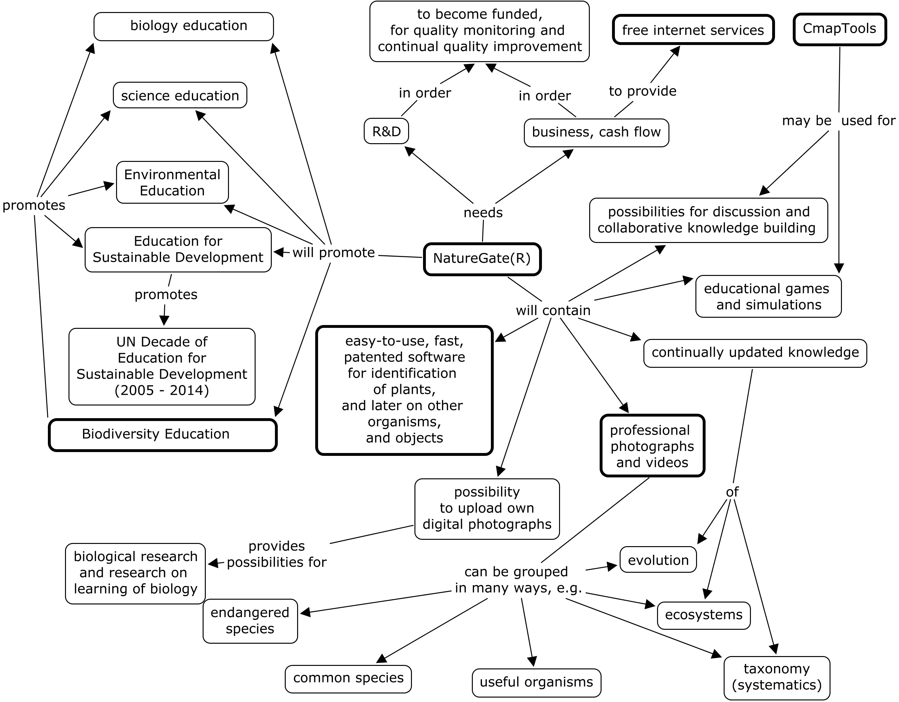

Figure 1. Main elements of the becoming free, international NatureGate® service. The six main concepts have thicker frames than other concepts. This concept map ought to be read following arrows from one concept to another. This concept map is created by free CmapTools software.
(Adapted from Ahlberg, Lehmuskallio & Lehmuskallio 2006a – 2006c).

(1) the starting point | (2) the next level | (3) the more advanced level
photographs and videos of flowering plants, and vascular plants in general, later on, all organisms. The easy-to-use, fast, patented software for plant species identification. | ecosystems and their free services for the whole humankind | sustainable development,  UN Decade of Education for Sustainable development  (2005 – 2014)
refer to | Refer to | refer to
concrete objects | both concrete and abstract objects, real ecosystems, the biggest is biosphere itself, can be represented by  systems models,  more abstract than individual species and specimens | very abstract objects and reasoning of very complex issues and problems of the real world. Involves plenty of high quality learning, thinking, and acting for sustainability, including biodiversity.
in order to | in order to | in order to
encourage studying, investigations, and inquiries of them in nature, outdoors, e.g. taking digital photographs and uploading them to NatureGate® server. | encourage studying, investigations, and inquiries of them in nature, outdoors, e.g. taking digital photographs and creating conceptual models, and dynamic models | encourage both individual and collaborative knowledge building and acting to promote sustainable development, including biodiversity.

Table 2. Some of the main content elements of NatureGate® R&D server on three levels.
(Adapted from Åhlberg, Lehmuskallio and Lehmuskallio 2006c)
References

Åhlberg, M. 1998. Education for sustainability, good environment and good life. In Åhlberg, M. & Leal Filho, W. (Eds.) 1998. Environmental education for sustainability: good environment, good life. Frankfurt am Main: Peter Lang, 25 - 43.

Åhlberg, M., Lehmuskallio, E. and Lehmuskallio, J. 2006c. N a t u r e G a t e® R&D and business program in progress. Handout for the poster in the meeting of the European Platform for Biodiversity Research Strategy (EPBRS) held under the Finnish Presidency of the EU. Helsinki-Espoo, 17.-19. November 2006,
http://bulsa.helsinki.fi/~maahlber/EU_Meeting_Hanasaari_16_19.11.2006.doc

Åhlberg, M., Lehmuskallio, E. and Lehmuskallio, J. 2006b.NatureGate® R& D and business program – a general description and a proposal for Sweden. Handout for the presentation in The Royal Swedish Academy of Sciences (Kungliga Vetenskapsakademien), The Swedish National Committee for Biology (Svenska Nationalkommittén för Biologi). Thursday, November 9, 2006, in the Linné Hall (Linnésalen), Stockholm, Sweden, http://bulsa.helsinki.fi/~maahlber/Vetenskapsakademien_9.11.2006.doc

Åhlberg, M., Lehmuskallio, E. and Lehmuskallio, J. 2006a. NatureGate®, concept mapping and CmapTools: Creating global networks of servers for improved learning about, in and for nature, ecosystems, biodiversity, and sustainable development. In Canas, A. & Novak, J. (Eds.) Concept Maps: Theory, Methodology, Technology. Proceedings of the Second International Conference on Concept Mapping. San José, Costa Rica - September 5-8, 2006. San Jose: Universidad de Costa Rica, 457 - 460,
http://cmc.ihmc.us/cmc2006Papers/cmc2006-p230.pdf#search=%22NatureGate%22

Åhlberg, M. & Schulman, L. 2006. Global ESD innovation in progress: NatureGate® in Biodiversity Education. In Young, J, Åhlberg, M., Niemelä, J., Parr, T., Pauleit, S. & Watt, A.D. (Eds.) 2006. Actions for the 2010 biodiversity target in Europe : How does research contribute to halting biodiversity loss? Report of the e-Conference, October 2006. Department of Biological and Environmental Sciences. University of Helsinki , 172.
All Species Foundation. 2007. Homepage, http://www.all-species.org/

Battelle, J. 2005. The search. How Google and its rivals rewrote the rules of business and transformed our culture. Boston: Nicholas Brealey Publishing.

Cairncross, F. 2002. The Company of the Future. Boston: Harvard Business School Publishing.

Cairncross, F. 2006. People, Science and Society: the Challenge of Climate Change - The British Association for the Advancement of Science. Presidential Address to the Festival of Science in Norwich (4 September 2006),
http://www.the-ba.net/the-ba/PressOffice/PressReleases/_PresAddress06.htm

CBD 2007. The Convention on Biological Diversity, http://www.biodiv.org/convention/default.shtml

Conservation International 2007a. Homepage, http://www.conservation.org/xp/CIWEB/

Conservation International 2007b. Biodiversity hotspots, http://www.biodiversityhotspots.org/xp/Hotspots/

Diversity of life. 2007. DOL (DiversityofLife.org), http://132.236.163.182/

EPBRS 2006a. EU EPBRS Recommendations concerning Biodiversity education, http://www.epbrs.org/PDF/EPBRS-FI2006-Education(final).pdf

EPBRS 2006b, HANASAARI DECLARATION ON BIODIVERSITY RESEARCH http://www.epbrs.org/PDF/EPBRS-FI2006-HanasaariDeclaration(final).pdf

IHMC. 2007a. IHMC CmapTools, http://tinyurl.com/2pmy9d

IHMC. 2007b. IHMC CmapTools Downloads, http://cmap.ihmc.us/download/

Tree of Life. 2007. Tree of Life eb project, http://www.tolweb.org/tree/

UNESCO. 2005. Draft International Implementation Scheme for the UN Decade of Education for Sustainable Development. UNESCO’s Executive Board,
http://unesdoc.unesco.org/images/0014/001403/140372e.pdf

Vise, D. & Malseed, M. 2005. The Google story. New York: Bantam Dell.

WRI. 2007. World Resources Institute, http://earthtrends.wri.org/ .

Young, J, Åhlberg, M., Niemelä, J., Parr, T., Pauleit, S. & Watt, AD (Eds.) 2006a. Actions for the 2010 biodiversity target in Europe: How does research contribute to halting biodiversity loss? Report of the e-Conference, October 2006, 26 pp.
http://www.epbrs.org/PDF/EPBRS-FI2006-EU2010TargetShort.pdf

Young, J, Åhlberg, M., Niemelä, J., Parr, T., Pauleit, S. & Watt, A.D. (Eds.) 2006b. Actions for the 2010 biodiversity target in Europe: How does research contribute to halting biodiversity loss? Report of the e-Conference, October 2006, http://www.edinburgh.ceh.ac.uk/biota/Archive_2010target/Long%20report_final.pdf

